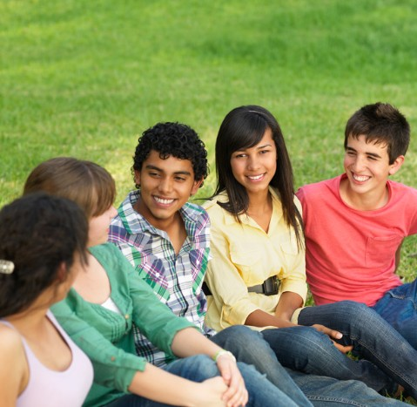

Wakefield Children and

Young People’s Health Survey


2026

Contents

Contents 2
Introduction 3
Headlines 4
Diet and Oral Health 6
Physical Activity 12
Free Time 15
Future Aspirations (Year 9) 18
Wellbeing and Sleep 20
What Makes a Good and Happy Life 24
Worries and Concerns 28
Bullying and Safety 32
Sexual Harassment 35
Sexual and Reproductive Health 37
Digital Inclusion 40
Neurodiversity (Year 9) 42
Alcohol and Drugs 44
Smoking and Vaping 47
Gambling 51
Appendix 1 Survey Participants 54
Appendix 2 General Methodology and Terminology 57
Appendix 3 Theming Open-Ended Responses 58

Introduction
The Children and Young People’s Health Survey provides a better understanding of the health, wellbeing, and behaviours of children and young people in Wakefield District.
Most participants completed the survey at their school or college. For the first time this year, we engaged with children who are electively home educated through specific organised events at local Council venues. Home educated children completed a shorter survey. Due to the small number of participants, results are not shown for the population in this report. However, this marks the beginning of a longer-term aspiration of engaging with the home educated population, strengthening relationships and gaining a greater understanding of their health and wellbeing needs.
Summaries produced for individual schools and colleges enable them, with health improvement specialists, to prioritise areas of learning that may be highlighted in the survey results. They can also inform interventions that they might need to take forward to address particular areas of health and wellbeing.
The analysis in this report looks at year groups and the pupil population as a whole and provides an important intelligence resource for strategic decision making. It also adds to the knowledge built up since the first survey almost two decades ago.
Fieldwork for the 2026 Children and Young People’s Health Survey ran from January to June 2026. Questionnaires for Year 5 (9-10 year olds), Year 7 (11-12 year olds), Year 9 (13-14 year olds), and Year 12 (16-17 year olds) were delivered using Snap Surveys on-line survey system. Throughout the survey, participants were signposted to additional support and advice about the topics covered.
Year 12 findings have not been included in this report. This is because the schools and colleges that participated in the survey did not provide sufficient representation of the wider Year 12 population. As a result, the responses may not accurately reflect the experiences and views of Year 12 students across the district. To avoid drawing potentially misleading conclusions, analysis and reporting of Year 12 responses has therefore been excluded from this report. Individual colleges who took part will still receive the summarised results for their school or college for Year 12.
7,421 questionnaires were completed from across 72 different schools and colleges. This included Year 12 students, and so 7,102 questionnaires from 70 schools were included in this report.
Some key questions have remained the same as in previous surveys, while new questions have also been added this time to collect information on topics such as digital inclusion and ketamine use (older year groups only). Some sections were also expanded to include more year groups, for example for the first time Year 9 children were asked about neurodiversity and how they were feeling about the future.

Thank you to the schools, colleges, and children and young people who completed the survey.

Headlines
Diet and oral health
- 70% of children ate fruit and vegetables every day or most days (up from 59% in 2020 and 44% in 2013).
- Children living in the most deprived areas, those from ethnic minority backgrounds, and those with special educational needs were all less likely to have visited the dentist in the last 12 months.
Physical activity
- Two in three children in Year 7 and Year 9 do the recommended amount of daily physical activity.
- The percentage of children who cycle once a week or more decreases with age, 49% in Year 5 vs 29% in Year 9.
- Children were most likely to currently take part in swimming, running, and football. Children would like to play more tennis, swim more and learn martial arts.
Free time
- Lots of children visited local green spaces in their free time including parks and playgrounds, younger children were more likely to visit the library, and older children were more likely to visit leisure centres.
- In Year 5, nearly eight in ten children read once a week or more, dropping to five in ten in Year 9.
Future aspirations (Year 9)
- The majority (over 60%) of Year 9 children were feeling good about relationships with friends, family, and their health in future. The majority also felt good about jobs, housing, money, and their ability to live independently. Less children felt good about climate change in the future.
- Girls felt less good than boys about most topics especially their health and job prospects.
Wellbeing and sleep
- Seven in ten children are happy with their lives at the moment. However, 45% felt lonely some or most of the time.
- Around one-third of Year 7 children (36%) and Year 9 children (31%) had high or maximum mental wellbeing scores. These results are the highest scores seen since the question was first asked in 2015.
What makes a good and happy life
- Family, friends, and relationships were the most common themes mentioned across all age groups when asked about what makes a good and happy life.
- Over two-thirds (69%) of children in Year 5 said that family were important.
- Friends and relationships became increasingly important with age.
Worries and concerns
- School and exams, family relationships, and friendship and peer groups were the most common themes mentioned across all age groups when asked what they worry about.
- Year 5 children were more likely to mention bullying and safety concerns.
- When asked how they respond to worries or concerns, Year 5 children were most likely to speak to someone about it (51%), whereas only 35% of Year 9 children said they would do this.

Bullying and safety
- Across all year groups one in ten children felt scared to go to school due to bullying.
- Children in Year 9 were less likely to say their school always dealt with bullying well (20%) compared to children in Year 5 (47%).
- Less than half of Years 7 and 9 felt safe travelling on public transport.
Sexual harassment
- Girls in Year 9 were much more likely to have experienced sexual harassment than boys.
- A high percentage of children in Year 9 had been taught about sexual harassment (91%) and knew who to report it to in school (83%).
Sexual and reproductive health
- Over a third of Year 9 children knew where to get free condoms, which is similar to previous surveys.
- Nearly one in ten girls in Year 9 had experienced period poverty.
Digital Inclusion
- In Year 7, one in 20 children never or only some of the time had access to a device for learning at home.
- There were inequalities for some; children with special educational needs, young carers and those from ethnic minority backgrounds were more likely to be digitally excluded.
Neurodiversity (Year 9)
- One in five Year 9 children self-identified as neurodiverse.
- Neurodiverse children were less likely to feel happy with life and less likely to feel safe in a variety of settings than their neurotypical peers.
Alcohol and drugs
- The percentage of Year 9 children who had tried alcohol has decreased over time, from 76% in 2013 down to 45% in 2026.
- 3% of Year 9 children had tried cannabis, which is similar to the percentage in previous years.
Smoking and vaping
- The percentage of Year 9 children trying smoking was lower than ever, with only 5% saying they had tried it.
- Second-hand smoke is still a concern, with 15% of Year 9 children reporting someone smoking inside at home.
- Although 21% of Year 9 children had tried vaping, only 2% said that they use vapes every day. Of those that vape weekly, 50% of Year 7 children and 24% of Year 9 children would like to stop.
Gambling
- 78% of children in Year 7 and 9 had tried one of the gambling activities asked about in the survey in the last 12 months. This is an increase of 9% compared to 2024.
- Boys were more likely than girls to gamble.

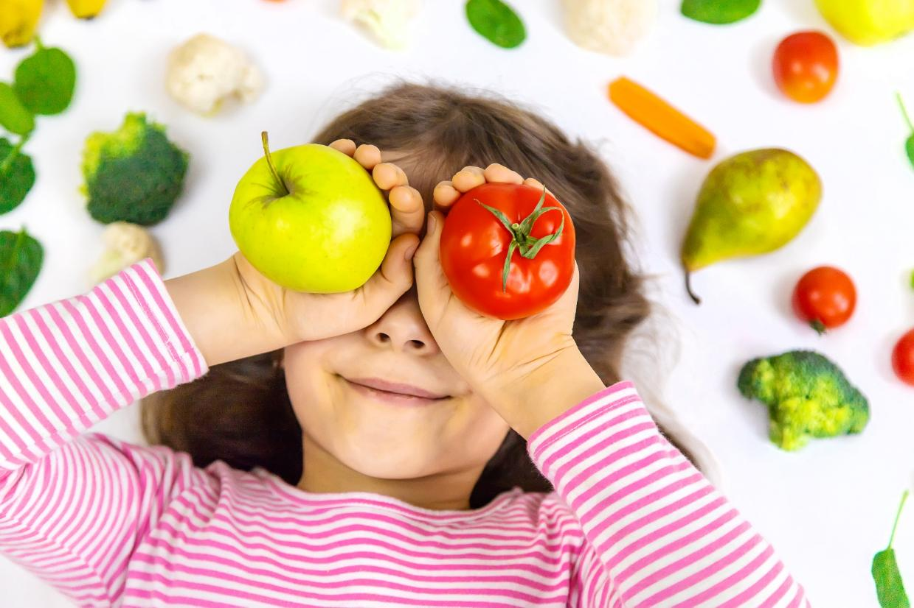

Diet and Oral Health
70% | of children ate fruit and vegetables every day or most days (up from 59% in 2020 and 44% in 2013). | 60% | of children would like to eat more healthily

21%  | 13%  | 73% 
of children had not eaten breakfast on the day of the survey (this increased with age). | of children ate fast food more than once a week with children living in the most deprived areas, ethnic minority children, those with special educational needs and young carers all more likely to do so. | of children had visited the dentist in the last 12 months with children living in the most deprived areas, ethnic minority children, and those with special educational needs all less likely to do so.

Children were asked several questions about their diet, including some questions about how often they ate certain types of food, and oral health.

Diet
Of the children in Years 5, 7 and 9 completing the survey, around one in five (21%) had not eaten breakfast that morning. Older children were less likely to eat breakfast than younger children (Figure 1).
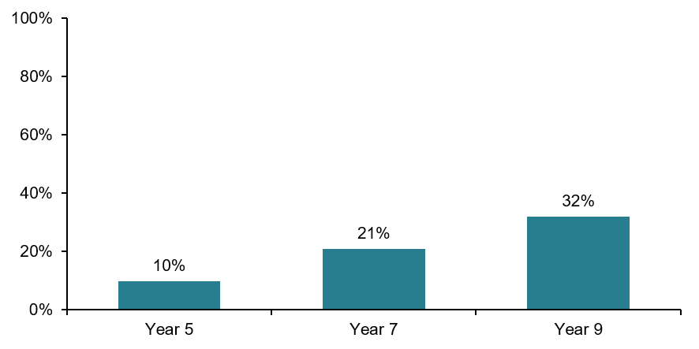
Figure 1 Percentage of children who had not eaten breakfast by year group.
The proportion of children not eating breakfast increased in 2022 but has gradually decreased back to levels similar to 2020. In Year 7 and Year 9, girls were more likely to have not eaten breakfast. In Year 9, children from ethnic minority backgrounds, young carers and children with special educational needs were also more likely to have not eaten breakfast.
It is recommended that children (over the age of 2) eat five or more portions of fruit and vegetables a day. Across Years 5, 7 and 9, 70% of children said they ate fruit and vegetables every day or most days (Figure 2), an increase on 59% in 2020 and 44% in 2013.
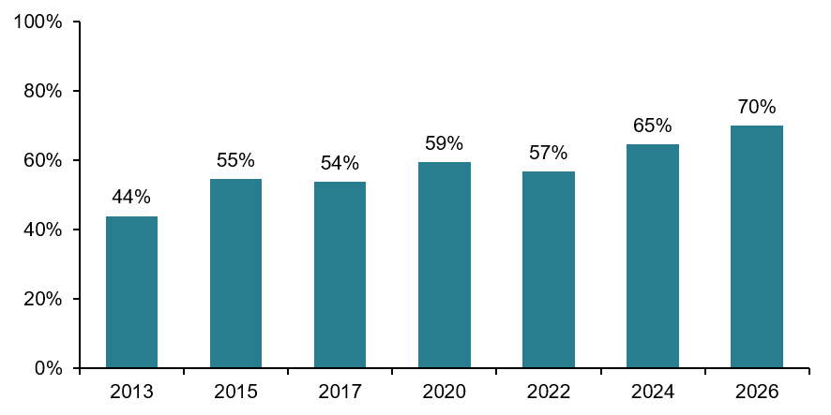
* Shows children in years 5 and 9 for 2013 to 2017, and children in years 5, 7, and 9 for 2020 onwards
Figure 2 Percentage of children who ate fruit and vegetables every day or most days by year.
Children living in the most deprived areas of the district and those with special educational needs were less likely to eat fruit and vegetables most days.
It is also recommended that as part of a balanced diet, children (over the age of 2) eat less saturated fat, sugar, and salt.
Across Years 5, 7 and 9:
- More than one in ten (13%) children said they ate fast food more than once a week
- One in four (26%) children said they drank fizzy drinks every day or most days
- Nearly half (48%) said they ate chocolates, crisps, or sweets every day or most days
Children living in the most deprived areas, those with special educational needs and young carers were all more likely to eat fast food more than once a week. In Years 7 and 9, children from ethnic minority backgrounds were more likely to eat fast food more than once a week compared to White British children (Figure 3).
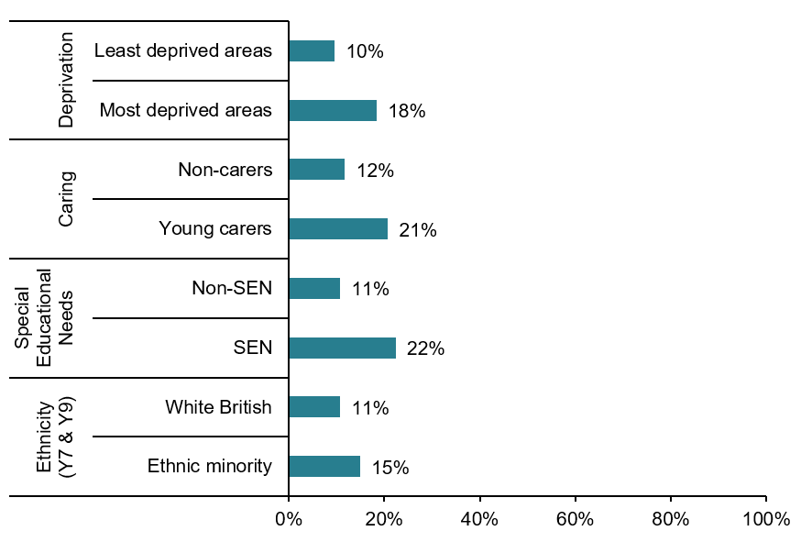
Figure 3 Percentage of children who ate fast food more than once per week, by inequality.

Children in Years 5, 7 and 9 were also asked about how often they consumed energy drinks. These are of interest as they contain high levels of caffeine and sugar and a commitment to ban their sale to under 16s by April 2027 has been made by the UK Government due to the evidence of significant health effects on children.
- More than one in ten (12%) children consumed energy drinks more than once a week
Older children were less likely to eat fast food more than once a week and chocolates, crisps, or sweets most days than younger children. Older children were more likely to drink fizzy drinks most days and energy drinks more than once a week than younger children (Figure 4).
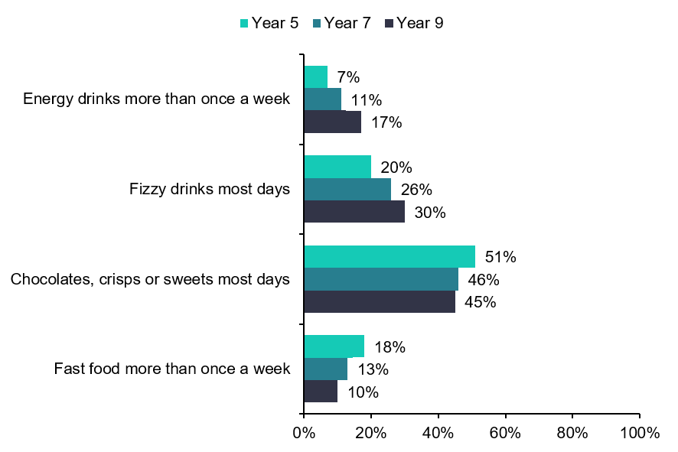
Figure 4 Responses to ‘How often do you eat or drink the following things…?’ by year group.
Of the children in Years 5, 7 and 9 completing the survey, three in five (60%) said they would like to eat more healthily.

Oral Health
For good oral health, NHS guidance recommends twice daily toothbrushing and regular visits to the dentist for a check-up for all children as soon as the first milk tooth appears.
Overall, nearly eight in ten children said they brush their teeth twice a day or more. Frequency of tooth brushing decreased in 2022, and though it has increased slightly in recent years, figures have not yet returned to previous levels (Figure 5).
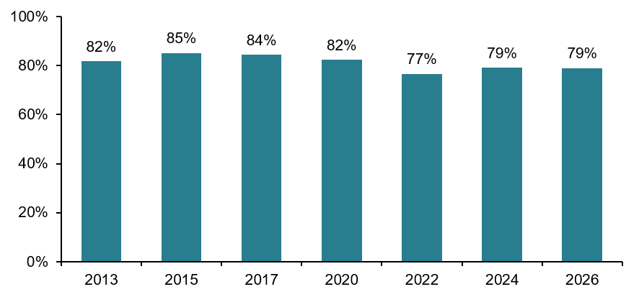
* Shows children in years 5 for 2013, years 5 and 9 for 2015 to 2017, and years 5, 7, and 9 for 2020 onwards
Figure 5 Percentage of children who brushed their teeth twice a day or more by year.
In all year groups, boys and children with special educational needs were less likely to brush their teeth twice a day.
Overall, over seven in ten children had been to the dentist in the last 12 months, and this increased with age (Figure 6).
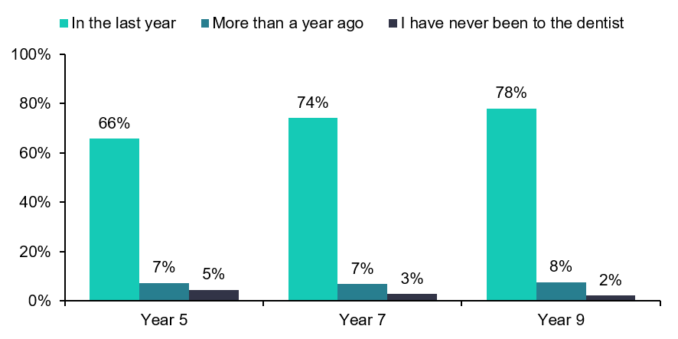
Figure 6 Responses to ‘How long age did you last go to the dentist?’ by year group.
Children with special educational needs, children from ethnic minority backgrounds (Year 7 and Year 9) and those in the most deprived areas of the district were less likely to have visited the dentist in the last 12 months (Figure 7).
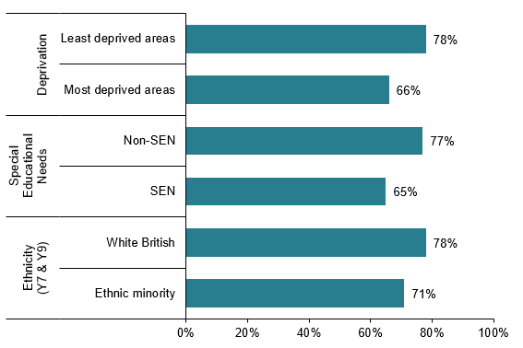
Figure 7 Percentage of children who have visited the dentist in the last 12 months, by inequality.
Children were also asked ‘How much of a problem’ their teeth were. The proportion of children who felt their teeth caused them a little or a lot of problems was highest in Year 5 and the proportion who reported no problems increased with age (Figure 8).
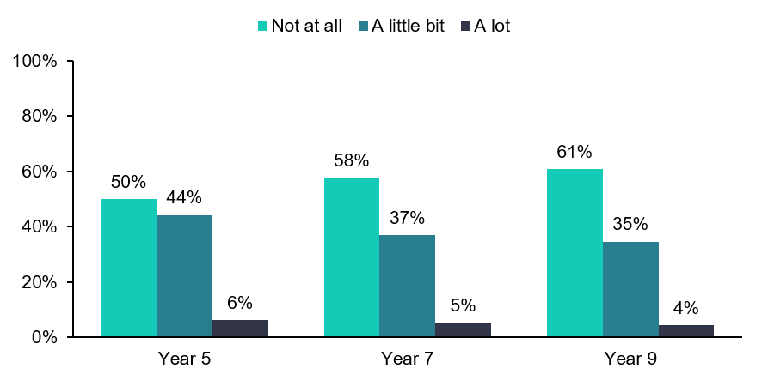
Figure 8 Responses to ‘How much of a problem are your teeth for you?’ by year group.



Physical Activity
80% | of children in Year 5 enjoyed physical activity a lot or quite a lot

67%  | 37%  | 41%  | 49% 
of Years 7 and 9 did more than one hour of activity per day | of those who do not think they do enough exercise felt they did not have the time to do more | of Years 5, 7 and 9 children walk to school | of Year 5 children cycle once a week or more dropping to 29% in Year 9 children

Physical activity is an important part of children’s health and wellbeing; the NHS advises that children and young people should aim for an average of at least 60 minutes of moderate or vigorous physical activity per day. The question about the amount of physical activity children did was asked differently by age; Year 5 were asked if they enjoyed physical activity, whereas Year 7 and 9 were asked if they did the recommended amount of at least an hour of activity a day.
80% of Year 5 children enjoyed physical activity a lot or quite a lot, and 68% of Year 7 and 66% of Year 9 do one hour or more of physical activity a day. Overall, girls were less likely to do the recommended amount of activity as well as children from ethnic minority backgrounds.
Participants were asked about the barriers they faced to doing physical activity; 43% of Year 5 children selected they were active enough already; this reduced to 34% among Year 9 children. The most common barriers to exercise amongst those who did not feel they did enough exercise were not having the time, not feeling bothered or motivated, or being worried about being laughed at or looking silly (Figure 9). Girls were less likely to say they were active enough already and more likely to be worried about being laughed at or looking silly than boys, at all ages.
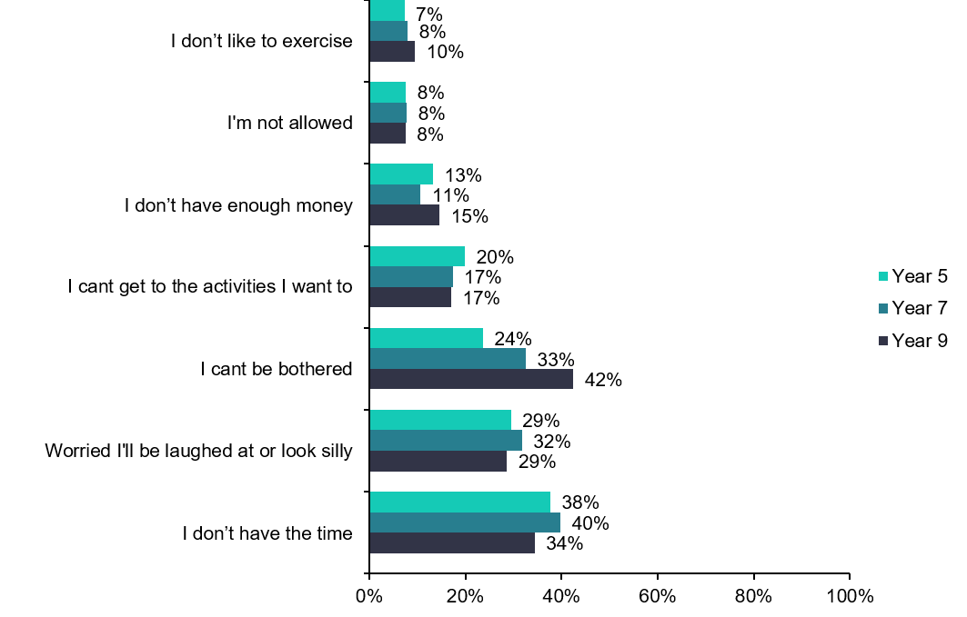
Figure 9 Barriers to exercise: percentage is of children who felt they were not active enough already.
Year 5 children were most likely to ride a bike once a week or more, with 49% doing so. Fewer children rode a bike weekly in the older year groups (Figure 10). Girls of all ages were much less likely to cycle regularly than boys. Year 5 children living in the district’s most deprived areas were less likely to ride a bike once a week or more, compared to children living in the district’s least deprived areas. Children with special educational needs in Years 7 and 9 were more likely to cycle regularly.
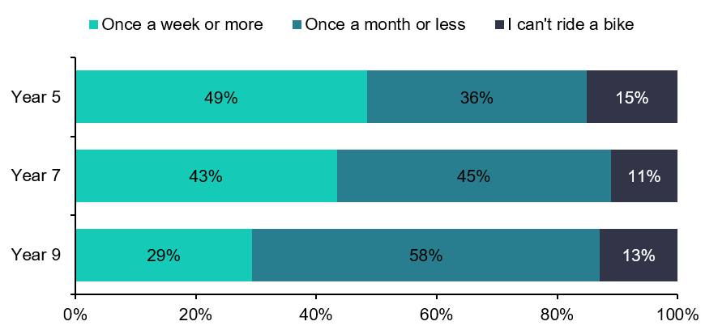
Figure 10 Summary of responses to the question ‘How often do you ride a bike?’
The sports that children were most likely to currently do were swimming, running and football, apart from Year 9 where cycling was also popular (Table 1). Of sports children would like to do, tennis, martial arts, basketball, swimming, and gym sessions all came in the top three for one or more year groups.
 | Year 5 | Year 7 | Year 9
Sports children currently do:
  1st | Swimming  64% | Running  45% | Running  40%
  2nd | Running  53% | Football  40% | Football  36%
  3rd | Football  45% | Swimming  35% | Cycling  25%
Sports children would like to do:
1st | Tennis  39% | Tennis  35% | Tennis  29%
2nd | Martial arts  33% | Swimming  32% | Swimming  26%
3rd | Basketball  33% | Martial arts  30% | Gym sessions  25%
Table 1 Most popular sports children do or would like to do amongst each year group.
Children were asked how they got to school. Across Years 5, 7 and 9 a similar proportion of children travelled to school by walking, with just over four in ten children getting to school this way overall (Figure 11).

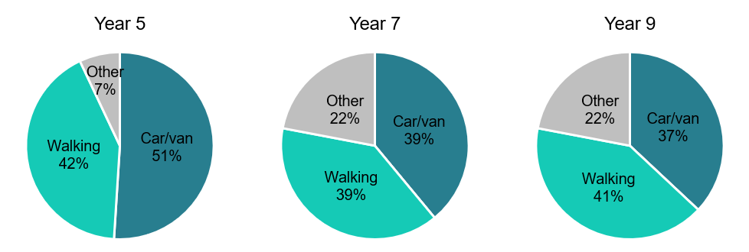
Figure 11 Mode of transport for getting to school (‘Other’ included bus, train, scooter, and cycle).

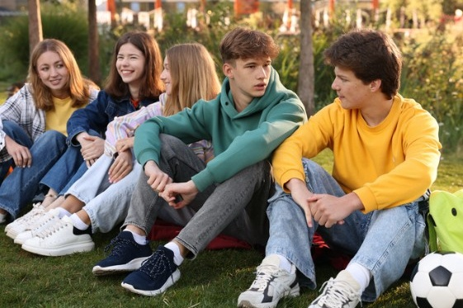

Free Time
34% | of Year 5 children said they go to the library once a month or more

38%  | 51%  | Girls  | Increases 
of Year 7 children went to the playground once a week or more | of Year 9 children visited a leisure centre once or more a month | were more likely to read once a week or more | with age, the percentage of children who never read in their free time

Children were asked how often they visit different places outside of school in their free time, this included green spaces and several places that are funded by the local authority (Figure 12). They were also asked if they read outside of school time.

Places Visited in Free Time
Green spaces like parks are recognised as important for children’s physical and mental health. In their free time it was found that 42% of Year 5 and 52% of Year 7 visited a park once a week or more and 23% of Year 5 and 34% of Year 7 visited the countryside once a month or more. Children from more deprived areas were less likely to visit the countryside.
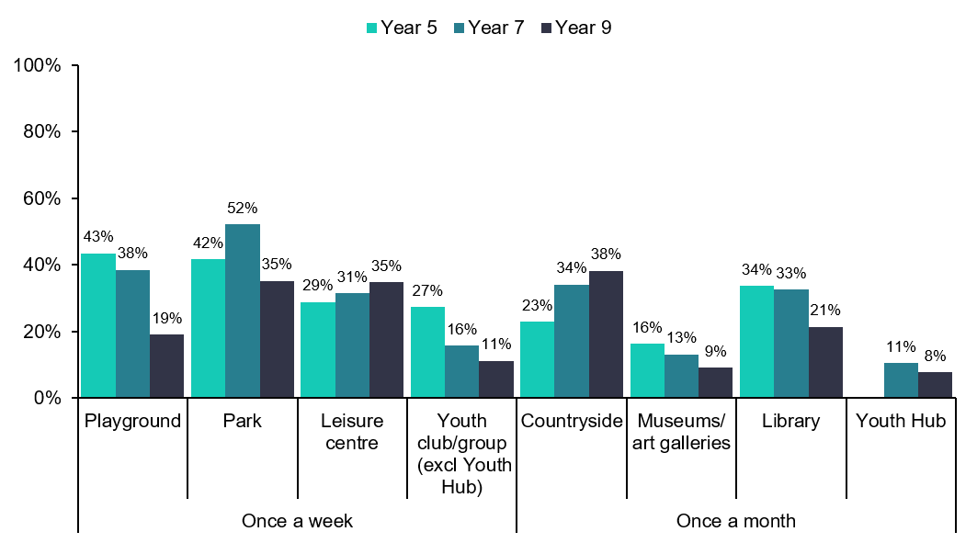
* Youth hubs are only for children aged 11-25 years old so Year 5 children were not asked about them
Figure 12 Places visited in free time.
Year 9 children were most likely to visit a leisure centre once a week or more and Year 5 and 7 were most likely to visit the library once a month or more. Across places visited, there were similar patterns of attendance across the inequality groups except girls and children from ethnic minority backgrounds were more likely to visit the library once a month or more and young carers and children with special educational needs were more likely to visit Council-run youth hubs once a month or more.

Reading
Children were also asked how often they read in their free time (Figure 13). Younger children were most likely to read once a week or more (78%), which is a higher percentage than in Year 9 (48%). In Year 5 children living in the most deprived areas and those with special educational needs were less likely to read at home. Children from ethnic minority backgrounds were less likely to read at home across all years. The results from this year cannot be compared to previous years as the question used to ask about reading a book at home but due to more people reading other types of media this now asked about reading at home without specifying a book.
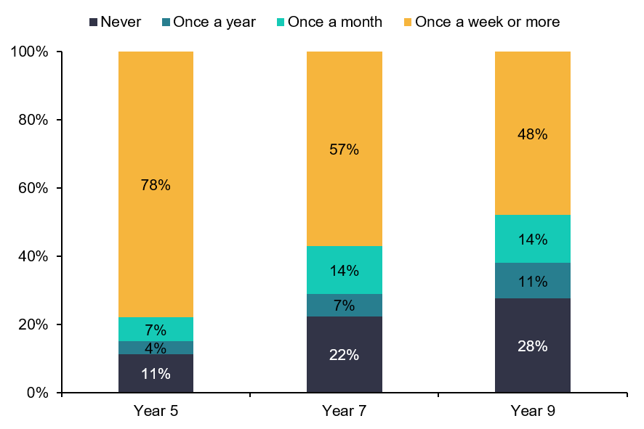
Figure 13 How often children read at home.



Future Aspirations (Year 9)
63% | of Year 9 children were feeling good about their future job prospects

  Relationships | 28%  | Girls  | 65% 
with family was the topic most Year 9 children felt good about | of Year 9 children were feeling quite or very bad about climate change | were less likely to feel good about a number of topics including health | felt good that they will be able to live independently in the future

Year 9 children were asked questions about how they were feeling about a number of aspects of life in their futures.

Survey responses showed children felt good about relationships with friends and family in the future but lower when considering having enough money or job prospects. Children were most likely to feel bad about climate change and a high percentage of children did not know whether they felt good or bad about this topic (Figure 14).
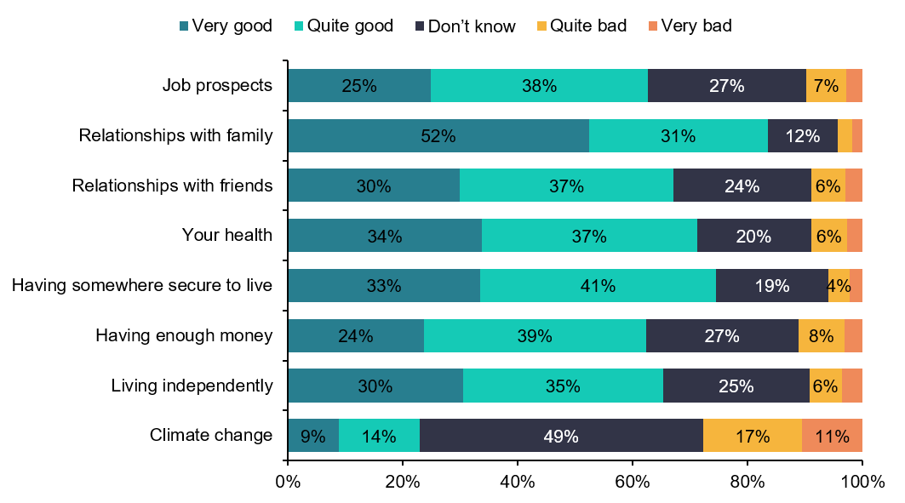
Figure 14 How Year 9 children are feeling about different topics when thinking about the future.
Amongst different groups girls tended to feel less good than boys especially about their health and job prospects. Children from ethnic minority backgrounds were less optimistic about their job prospects and relationships with family. Young carers were less optimistic about having enough money, their health, and relationships with family. Those with special educational needs were less optimistic about job prospects, having enough money, having somewhere secure to live and their health. Those from the most deprived areas were less optimistic about their health than those from the least deprived areas.



Wellbeing and Sleep
69% | of children were happy with their lives at the moment

34%  | 20%  | 45%  | 5% 
had high mental wellbeing scores | had low mental wellbeing scores | felt lonely some or most of the time | were experiencing  bed poverty

All children were asked how happy they feel with their lives at the moment and also how often they feel lonely. In addition, the general mental wellbeing of children in Years 7 and 9 was measured using the Short Warwick-Edinburgh Mental Wellbeing Scale (SWEMWBS), a scientifically validated set of questions. See Appendix 2 for details on the SWEMWBS categories used in this report. Children were also asked how much sleep they usually got on a school night.

Happiness and Loneliness
The proportion of children feeling lonely some or most of the time (45%) has decreased in recent years, but still slightly above levels seen in 2020.
Overall, 69% of children said they were quite or very happy with their lives at the moment. There has been an upward trend in recent years, but still slightly below levels seen in 2017 (Figure 15).
However, levels of happiness have not improved for everyone. Since 2024, there has been no significant improvement in levels of happiness among young carers or children with special educational needs.
Boys were happier and less likely to be lonely than girls in all the year groups surveyed. Young carers and children with special educational needs were less happy and more likely to be lonely than their counterparts in all the year groups surveyed.
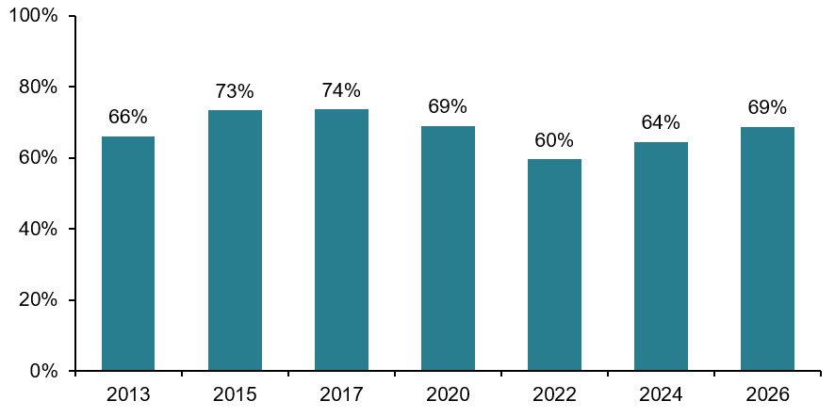
Figure 15 Percentage of Year 5, 7 and 9 children who feel happy with life at the moment.

Wellbeing
Around one third of Year 7 children (36%) and Year 9 children (31%) had high or maximum mental wellbeing scores. These results are the highest scores seen since the question was first asked in 2015.
Around one in five (20%) Year 7 and Year 9 children had low mental wellbeing.
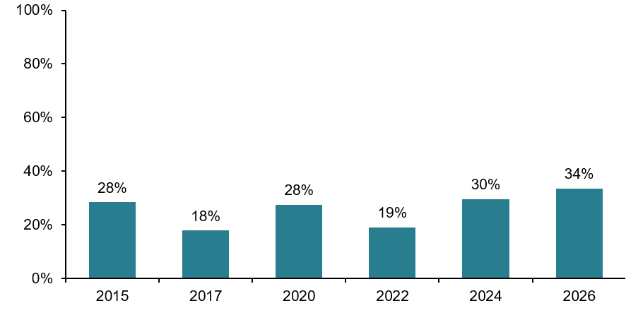
Figure 16 Percentage of Year 7 and 9 children with high or maximum mental wellbeing scores.
Boys were more likely than girls to have high levels of mental wellbeing. Young carers (Years 7 and 9) and children with special educational needs (Year 7) were less likely than their counterparts to have high levels of mental wellbeing.
Comparing mental wellbeing with other aspects of children’s health reveals that children with low mental wellbeing were more likely to vape at least once a week (4% compared to 1% of other children) and were more likely to drink alcohol at least once a week (4% compared to 1% of other children).
Year 9 children with low mental wellbeing were more likely to say they would cut or harm themselves (25%) if they were worried about a problem or stressed, than other children (2%).

Sleep
Poor sleep has been linked with difficulties in paying attention in class, keeping up with schoolwork, forgetfulness, and absenteeism .
Younger children generally get more hours sleep on a school night than older children. Only 22% of Year 5 children said they got seven hours sleep or less, compared to 49% of Year 9 children.
In Year 9, girls had fewer hours sleep than boys. Across all year groups, young carers and children with special educational needs were less likely to have eight or more hours sleep compared to their counterparts.

Bed Poverty
Bed poverty can include broken beds and damaged bedding; sharing beds and rooms; sleeping on the floor; or families being unable to wash or dry bedding properly. Not having their own bed may have consequences for a child’s physical and mental health.
11% of Year 5 children said they share a bed most of the time or sleep on something other than a bed (e.g. a sofa or the floor). 4% of Year 7 children and 3% of Year 9 children said the same (Table 2). These figures are similar to those seen in 2024 when the question was first introduced.
 | Year group
Where do you sleep most of the time? | 5 | 7 | 9 | Total
I sleep in my own bed | 89% | 96% | 97% | 95%
I share a bed (e.g. with siblings/parents/carers) | 9% | 3% | 2% | 5%
I sleep on something else other than a bed (e.g. sofa/floor) | 1% | 1% | 1% | 1%
Table 2 Summary of responses to the question ‘Where do you sleep most of the time?’.
In Years 7 and 9, children from ethnic minority backgrounds were more likely to experience bed poverty (8% for Year 7 and 6% for Year 9), compared with White British children (3% for Year 7 and 1% for Year 9). Ethnicity was not recorded for Year 5 children.
9% of children who live in the district’s most deprived areas shared a bed most of the time or sleep on something other than a bed, compared to 5% in the district’s least deprived areas (Figure 17).
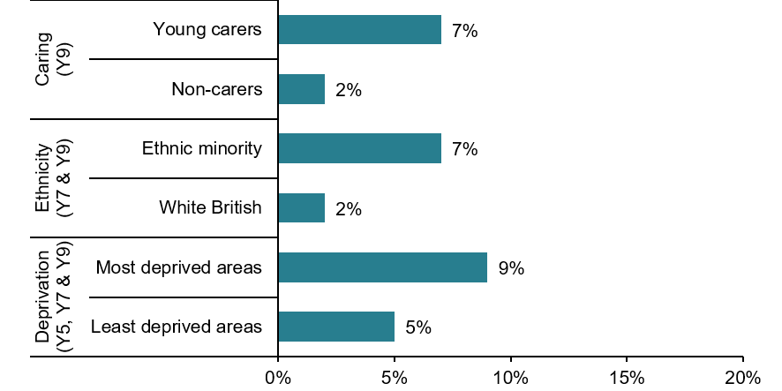
Figure 17 Percentage of children experiencing bed poverty, by inequality.



What Makes a Good and Happy Life
86% | of children across all year groups said that positive relationships were important

Family, friends, and relationships | Older  | Hobbies
were most commonly highlighted across all year groups as the  main things that make a  good and happy life | children were more likely to say friends and relationships were important | were important including sports, arts, gaming and technology, and other activities

This year's survey included a new open-ended question where children were asked, ‘What are three things that you think make a good and happy life?’ The responses to the questions were collated and placed into themes. Two separate categories were used to group responses and are presented in this section – a category of eight overarching themes and a category of more detailed themes. See Appendix 3 for further details on the theming methodology used.

Around one in five (19%) children across all year groups did not answer this question. Children in Year 9 were less like to answer than younger children (Table 3).
 | Year group
 | 5 | 7 | 9
Did not provide any answer / thoughts | 14% | 17% | 24%

Table 3 Children who did not provide any answer to the question.

Overarching Themes (Figure 18)
Those who did not provide any answer or thoughts were excluded from the analysis in this section. In the overarching theme, positive relationships were the main thing children across all year groups highlighted as important for a good and happy life (Figure 18). More than four in five (86%) children in each year group provided responses that were themed in this way, including relationships with family, friends, future partners, and pets. Two in five (41%) children across all age groups highlighted hobbies as important.
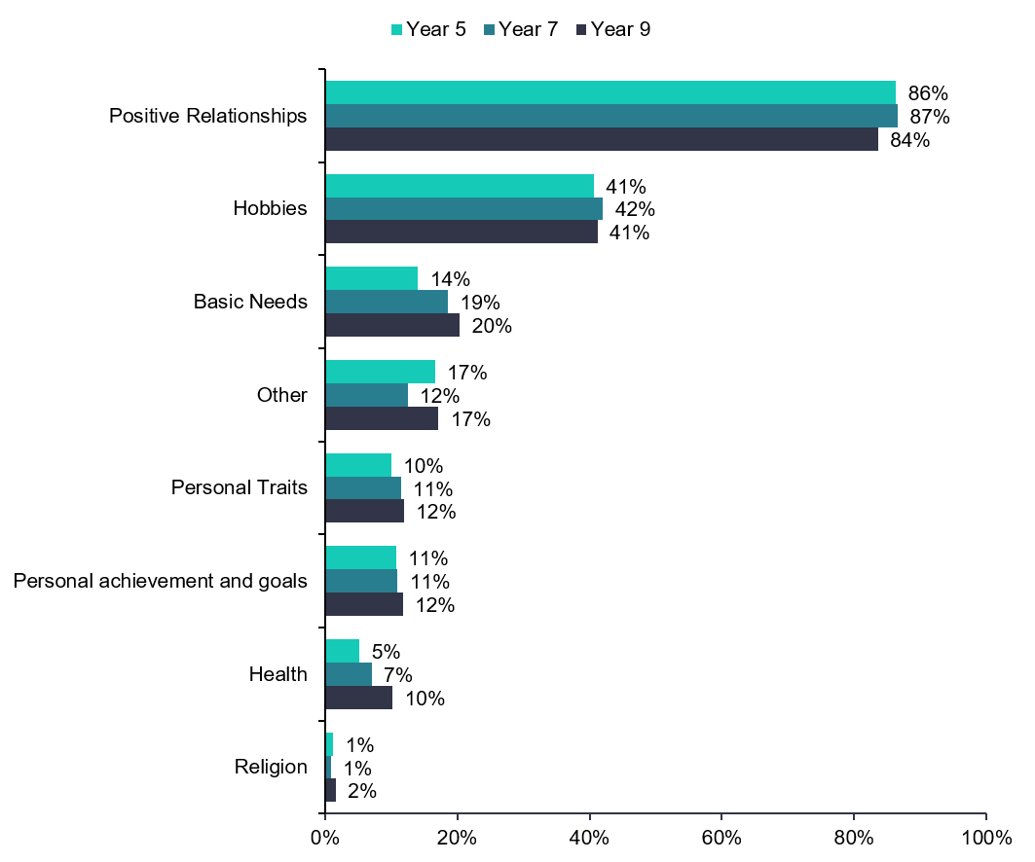
Figure 18 Children’s thoughts on what makes a good and happy life (overarching themes).

Detailed Themes (Figure 19)
Across all year groups, children often highlighted family and friends and relationships as things that made a good and happy life. Over two-thirds (69%) of children in Year 5 said that family were important (Figure 19). Friends and relationships became more important with age – 57% of Year 9 children highlighted them as important parts of a good and happy life.
Around one in four children across all year groups provided responses themed under sport and physical activity. Alongside responses that stated being active was important to them, children also included a wide range of activities including dance, gymnastics, football, rugby, and cycling, as well as attending sports events.
Good physical and/or mental health was specifically stated by children in some cases and became more important with age.
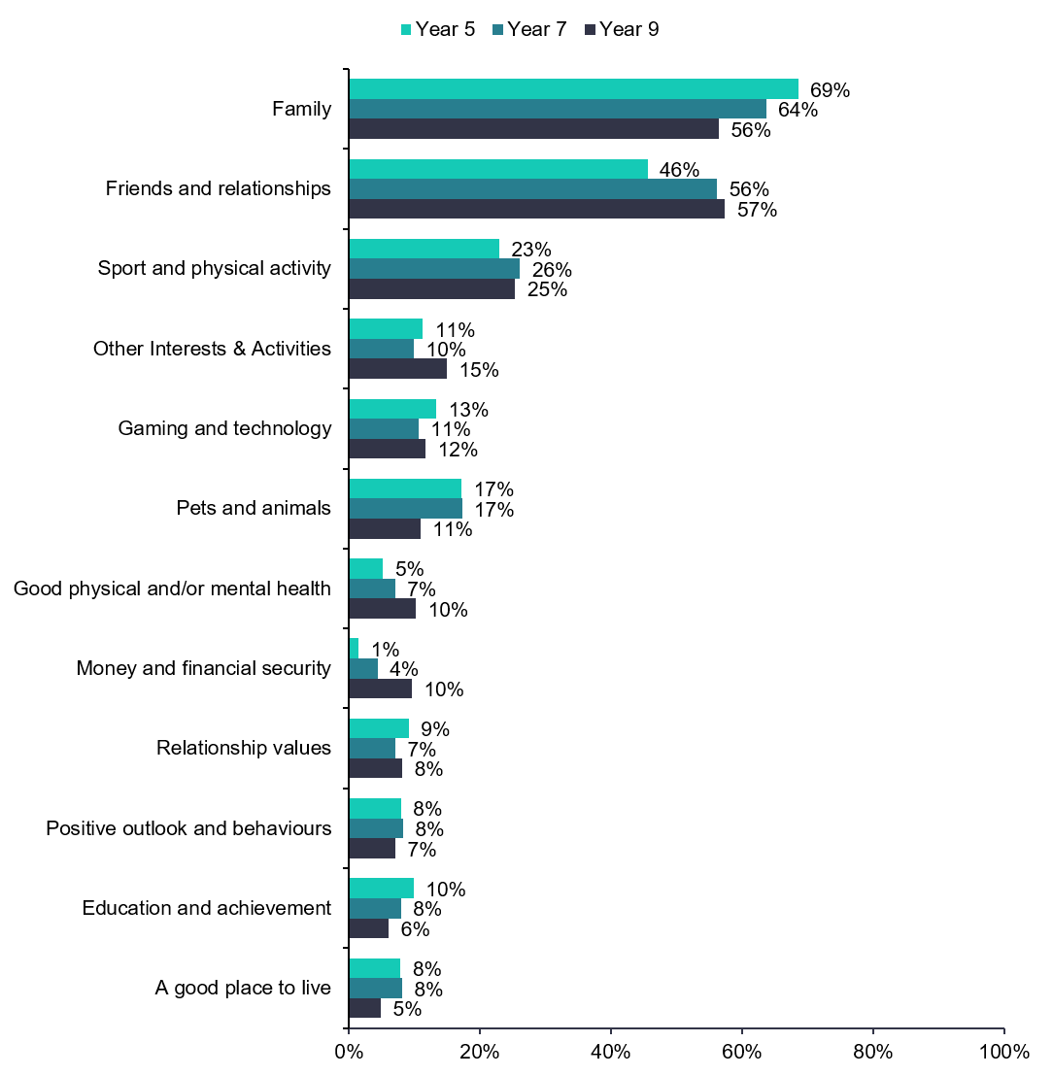
Figure 19 Children’s thoughts on what makes a good and happy life (themed).
In addition to Figure 19, there were also other themes highlighted including future aspirations, freedom and self-expression, travel and holidays, being safe, possessions, and access to food and water.
When split by gender, there was marked variation in some themes (Figure 20). Analysis by gender presented in this section does not include those who described their gender in some other way due to the small number of children involved.
Relationships with family and friends were important for most children, although a higher percentage of girls across all year groups highlighted these as important, compared to boys. More than two-thirds (68%) of girls across all year groups.
Across all year groups, boys were more likely to highlight sports and physical activity, gaming, and technology as important compared to girls. Girls were more likely to highlight arts and culture, pets, and animals.
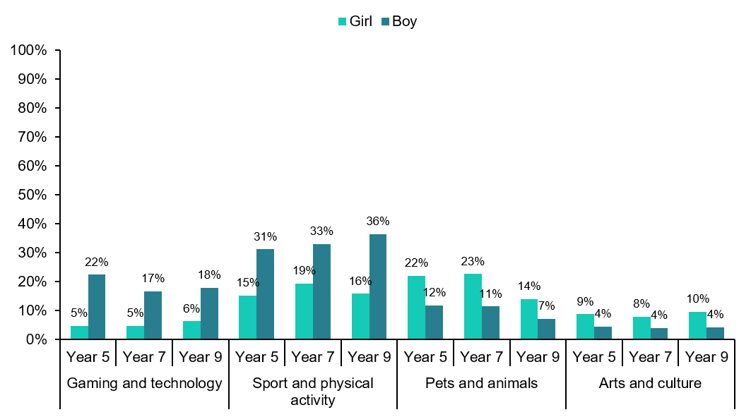
Figure 20 Children’s thoughts on what makes a good and happy life (themed), by gender.



Worries and Concerns
52% | of Year 9 children said that school and exams were a worry for them

10% | Higher  | Younger | 54% 
of children said they do not worry about anything in Years 5,  7, and 9 | percentage of girls said they worried about school and friendships,  compared to boys | children were more likely to highlight worries around family, bullying and safety | Of Year 9 children listened to music when they are worried or stressed

Similar to the previous section, this year's survey included a new open-ended question where children were asked, ‘Thinking about your life right now, what are the three things you worry about the most?’. The responses to the questions were collated and placed into themes.
As in previous years, children were also asked about how they cope with or respond to the worries or concerns they have (see Appendix 3 for further details on the theming methodology used).

Main Worries and Concerns
As you would expect, children in different year groups have different worries and concerns. One in four (25%) children across all year groups did not answer this question, although this varied between year groups (Table 4).
 | Year group
 | 5 | 7 | 9
Did not provide any answer / worries | 21% | 25% | 28%

Table 4 Children who did not provide any answer to the question.
Those who did not provide any answer or worries were excluded from the analysis in this section. School and exams were the main worry across all year groups; however, it became more prominent in older year groups (Figure 21). More than half (52%) of children in Year 9 said that school and exams were a worry for them. A similar pattern was seen regarding worries about the future and mental health and anxiety.
One in five (20%) Year 5 and one in four (25%) Year 7 and Year 9 children provided responses around friendships and peer group worries. Worries about family impacted Year 5 children more than older children (27%). This included family relationships, worrying about parents, siblings or elderly relatives, and home situations. Bullying was a worry for 18% of Year 5 children but less of a worry for older year groups.
One in ten (10%) children across all year groups specifically said they do not worry about anything or could not state a worry, however this varied between year groups with only 7% of Year 9 children saying they had no worries.
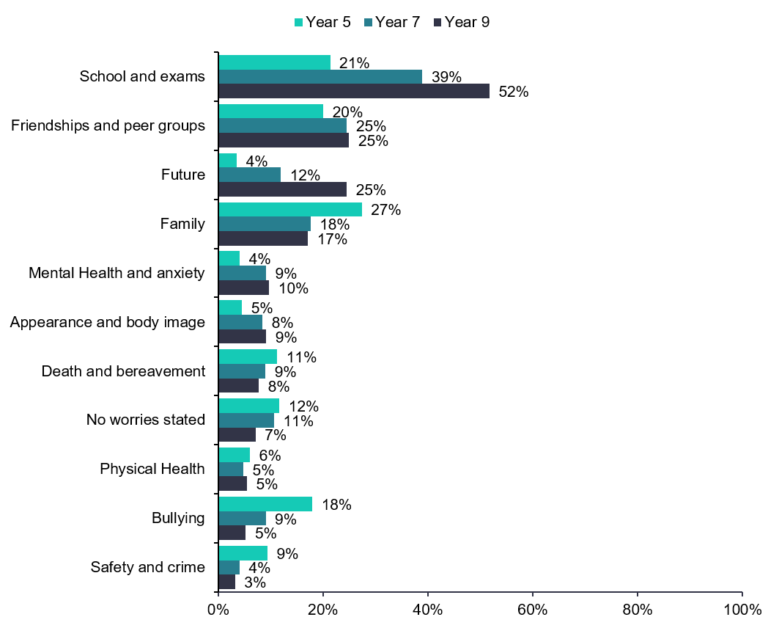
Figure 21 Children’s worries and concerns (themed).
In addition to the above, there were also other themes highlighted including concerns about money and the cost of living, sports and performance, pets, world events, online activities and gaming, and potential injuries.
There was significant variance when looking at worries and concerns between genders (Figure 22). Analysis by gender presented in this section does not include those who described their gender in some other way due to the small number of children involved.
A higher percentage of girls worried about school and exams in Years 7 and 9 – almost 60% in Year 9. Just under a third (31%) of girls and children who describe their gender in a different way in Year 9 had friendship and peer group worries, compared to only one in six (17%) boys. Appearance and body image was more of a concern for girls across year groups. Children who describe their gender in a different way had a much higher percentage of Mental Health and anxiety worries (38%), compared to both boys and girls (6% and 12% respectively). Boys were more likely to specifically state they do not worry about anything or could not state a worry across all year groups.
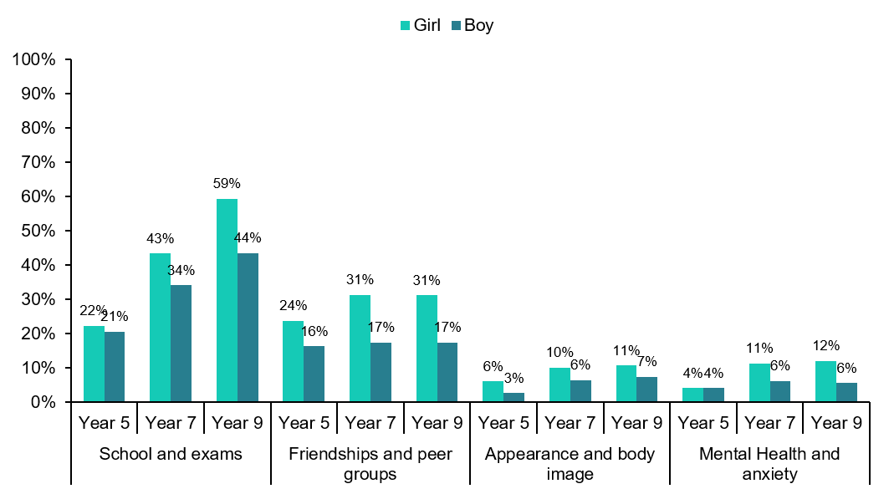
Figure 22 Children’s worries and concerns (themed), by gender.

Response to Worries and Stress
Listening to music, watching TV/playing computer games, or talking to someone are the things children are most likely to do if they worried or having problems (Table 5). Younger children are more likely to talk to someone about worries or stress, and older children were more likely to rest and sleep more or think about the problems themselves than younger children.
7% of Year 9 children said they might cut or hurt themselves when they are worried or stressed and 3% said they might drink alcohol or smoke/vape. Looking at Year 9 results by gender, girls were more likely to cut or hurt themselves (11%) than boys (2%) and were more likely to listen to music, rest, or sleep more than boys. Boys were more likely to do physical activity.
Response to worries or problems | Year group
Response to worries or problems | 5 | 7 | 9
Listen to music | 31% | 47% | 54%
Watch TV / play computer games | 33% | 48% | 50%
Talk to someone about it | 51% | 43% | 35%
Rest or sleep more | 19% | 30% | 41%
Think carefully about the problem by yourself | 21% | 27% | 37%
Do physical activity | 17% | 27% | 28%
Eat or drink more (e.g. sweets, chocolates) | 13% | 16% | 19%
Seek help with the problem online | 3% | 3% | 3%
Cut or hurt myself | * | * | 7%
Have a drink of something alcoholic | * | 1% | 3%
Smoke cigarettes/vape | * | 1% | 3%
* These options were not given to those year groups
Table 5 How children in each year group responded to worries and concerns.

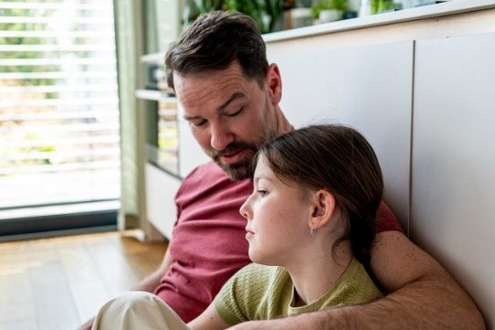

Bullying and Safety
10% | of children across Years 5, 7 and 9 felt scared of going to school because of bullying

Appearance | 1 in 3  | 8 in 10  | 16% 
was the most common reason for being bullied | children had been bullied inside school | children felt safe in the area where they live | of Year 9 children felt unsafe at school

Bullying in childhood is a major public health problem that increases the risk of poor health, social and educational outcomes in childhood and adolescence. The consequences may also last deep into adulthood. The survey asked children whether they ever felt scared of going to school because of bullying, and if they had been bullied what they thought the reasons were. Children were also asked where any bullying had taken place, and whether they thought their school dealt with bullying well or badly. In addition, children were asked how they feel in the area in which they live, at school, at home, travelling on public transport and online.

Bullying
Across Years 5, 7 and 9, 10% of children said they felt scared of going to school because of bullying, with very little difference between the year groups. There was no change since 2024 in the proportions of children saying they felt scared of going to school because of bullying. Looking at previous trends, percentages have been higher over the last three surveys than previously (Figure 23).
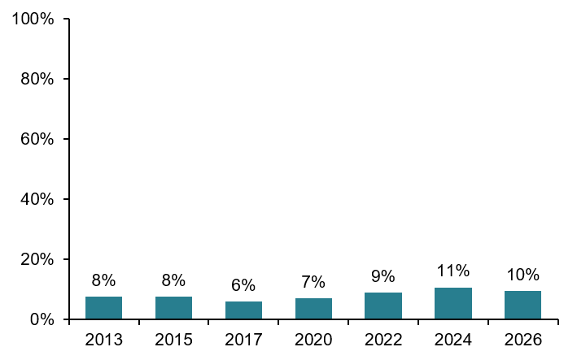
Figure 23 Trends in percentage of children scared to go to school due to bullying in Year 9.
Girls, young carers, and children with special educational needs were more likely to say they were often scared of going to school because they are being bullied. The main reasons children reported being bullied were their size or weight, the clothes that they wear or other aspects of their appearance (Table 6).
Reason | Year 5 | Year 7 | Year 9
The clothes or shoes you wear | 6% | 6% | 9%
Your size or weight | 17% | 24% | 30%
Something else about your appearance | 18% | 30% | 34%
A disability or learning difficulty | 4% | 7% | 7%
Where you live | 2% | 2% | 3%
Your gender | 3% | 5% | 5%
Your gender identity* | * | * | 1%
Your race or skin colour | 4% | 5% | 8%
Your religion or faith | 2% | 2% | 3%
* Year 5 and 7 were not asked about gender identity. More than one option could be selected.
Table 6 Reasons children were bullied.
Among children with special educational needs, 21% had ever been bullied because of a disability or learning difficulty compared to 3% of other children, and among children from ethnic minority backgrounds, 24% had been bullied because of their race compared to 1% of White British children.
When asked where they were bullied, 52% of children said they had not been bullied, 35% said they had been bullied in school, 16% had been bullied outside school, and 14% had been bullied online (children could select being bullied in more than one place). There was relatively little difference between the year groups and breakdowns are similar to the last survey in 2024.
Nearly half (47%) of Year 5 children thought their school usually dealt with bullying well, but only 20% of Year 9 children shared this view (Figure 23).
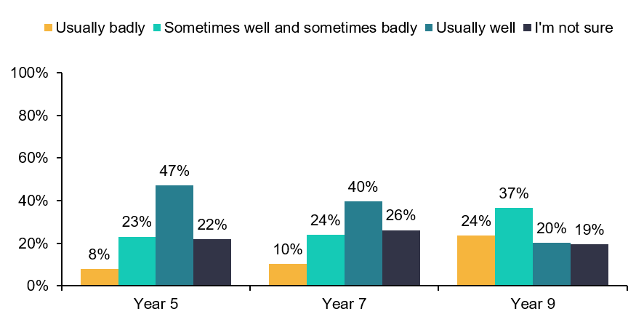
Figure 23 How children felt their school dealt with bullying by year group.

Safety
The majority of children felt safe or very safe where they live (80%) and percentages were also high for feeling safe at school, with 75% of Year 5 children feeling safe dropping to 65% in Year 9. The vast majority of children felt safe in their home. Figures were lower for feeling safe online with younger children less likely to say they feel safe online (49% in Year 5 vs. 68% in Year 9). Year 7 and Year 9 children were asked about public transport and less than half of those asked felt safe (Figure 21).
Across all years, girls felt less safe online and in Year 7 and Year 9 they also felt less safe at home, at school and on public transport. Those from ethnic minority backgrounds also felt less safe online and in school. Young carers also felt less safe than other children in the area where they lived, at home, at school (Year 9 only), on public transport (Year 7 only) and online, a similar pattern was found for children with special educational needs. Children from more deprived areas were less likely to feel safe in the area where they live across all year groups.
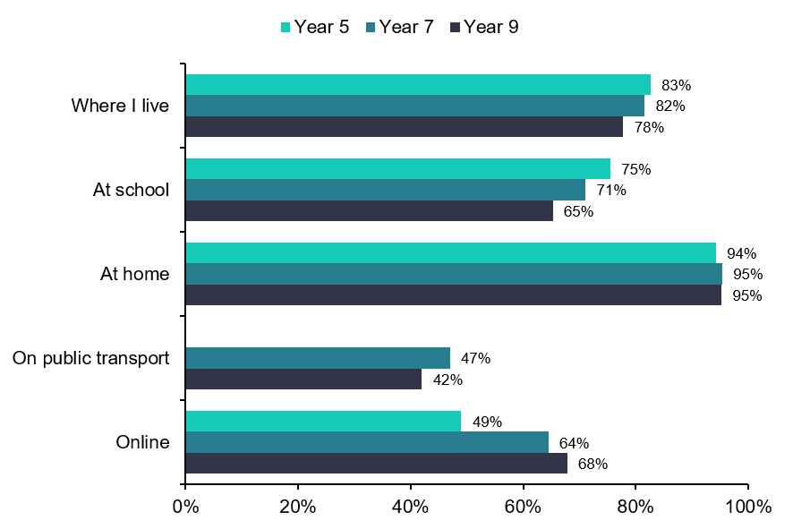
Figure 21 Percentage of children feeling safe or very safe by year group in different places.
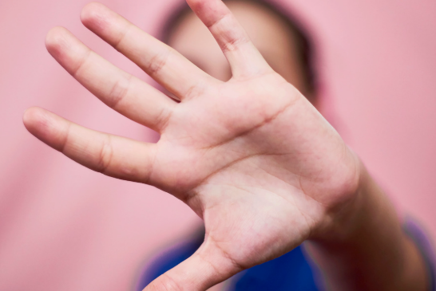

Sexual Harassment
27% | of Year 9 children had been sexually harassed by another young person or a group of young people
Sexualised comments |  | Girls  | 91%  | 83% 
was the most common type of sexual harassment |  | in Year 9 were much more likely to be sexually harassed than boys | of Year 9 children had been taught about sexual harassment at school | of Year 9 children knew who to report sexual harassment to in their school

Raising awareness of what sexual harassment is and its impacts is part of the Personal, Social, Health and Economic (PHSE) curriculum in schools or is delivered through online safety or other information sessions. It can be taught at any time whilst a child is at high school, but when it is delivered may vary between schools. In the survey 72% of Year 7 and 91% of Year 9 children said they had been taught about it in school. The percentage of respondents who had experienced sexual harassment was higher among the older year group (Figure 22).
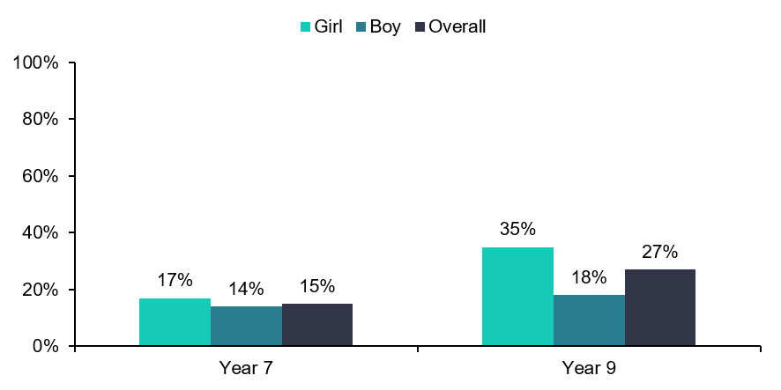
Figure 22 Percentage of respondents experiencing sexual harassment overall and by gender.
Girls were much more likely to experience sexual harassment than boys in Year 9, this gap was not as apparent in Year 7 (Figure 22). The most common types of sexual harassment for Year 9 children were sexualised comments/banter and being shown sexual images they did not want to see (Figure 23). Most children knew who to report sexual harassment to in their school, 77% in Year 7 and 83% in Year 9.
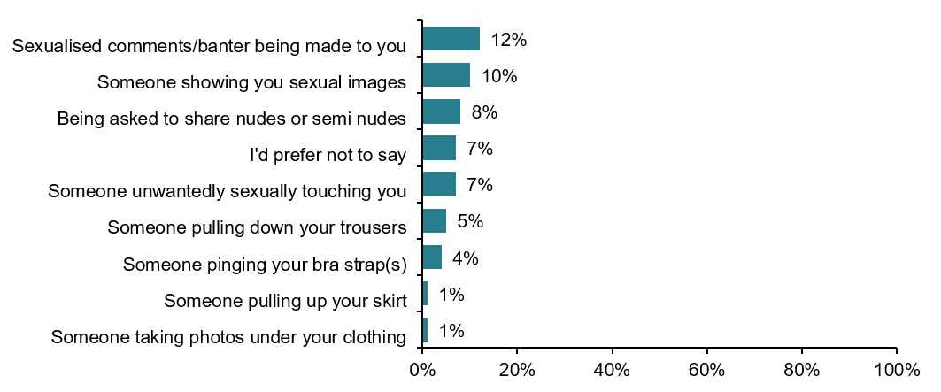
*More than one option could be selected
Figure 23 Types of sexual harassment experienced by Year 9 children.

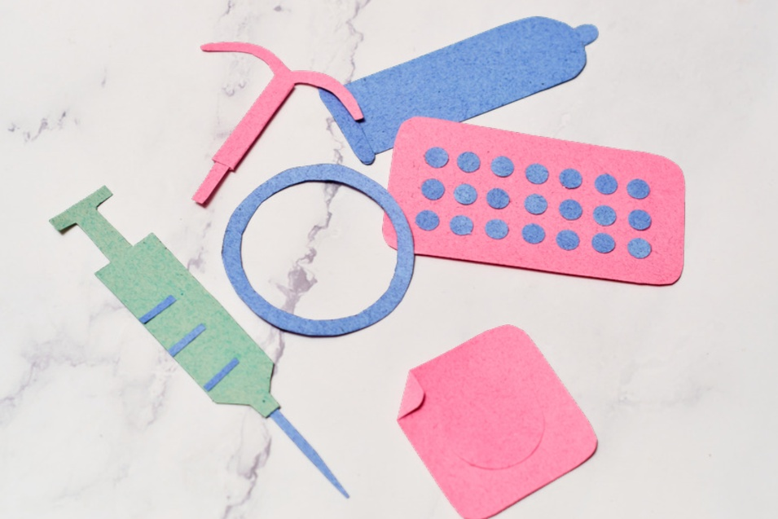

Sexual and Reproductive Health
34% | of Year 9 children knew where to get free condoms

45%  | Nearly  1 in 10 | 66%  | 21% 
of Year 9 children felt confident in establishing consent with a sexual partner | girls in Year 9 had experienced period poverty.  Icon Created by IYIKON from the Noun project | of Year 9 children agreed they could describe the laws relating to age of consent for sexual relationships | of children experiencing period poverty were scared to go to school due to bullying.

Sexual Health
Year 9 children were asked a number of questions relating to sexual health including how well they thought they understood issues surrounding consent, whether they had felt under pressure to have sex and whether they knew how to access condoms.
When asked if they agree with different statements about sexual relationships and consent, two thirds of Year 9 children agreed they could describe the laws relating to age of consent (Figure 24).
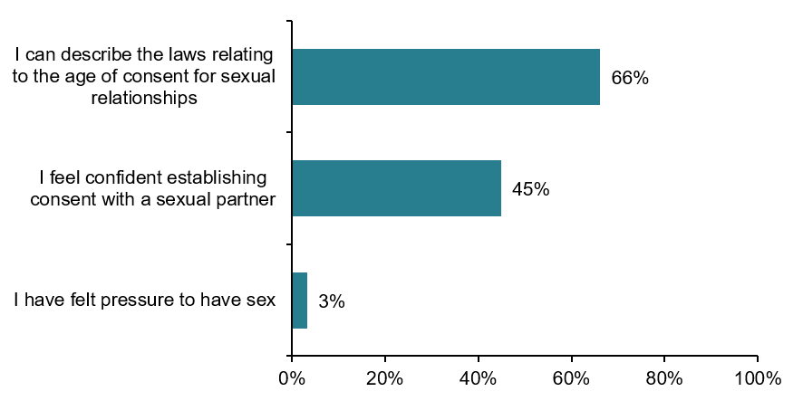
Figure 24 Percentage of Year 9 children who agreed or strongly agreed with the given statements.
In Wakefield District if you are aged between 13 and 24 years old you can register for a C-Card which offers access to a number of sexual health services including free condoms and STI testing. Very few children in Year 9 had had sex (<3%) and 34% knew where to get condoms for free. Trends show there was previously a drop in the number of children in Year 9 knowing where to access condoms for free, but this has plateaued (Figure 25).
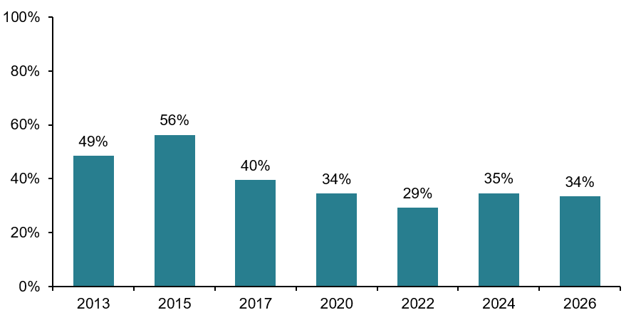
Figure 25 Trends over time for the percentage of Year 9 children who know where to get condoms for free.

Period Poverty
Periods usually begin at around the age of 12 (Year 7), but individual age varies. Period poverty means a lack of access to proper period products or the education needed to use them effectively. This can cause physical health problems and lead to missed school days and stigma. Not being able to afford period products may be indicative of low income and poverty more generally.
Nine percent of Year 9 children who identified as a girl said they had experienced not being able to afford period products, as well as 4% of girls in Year 7 (Figure 26).
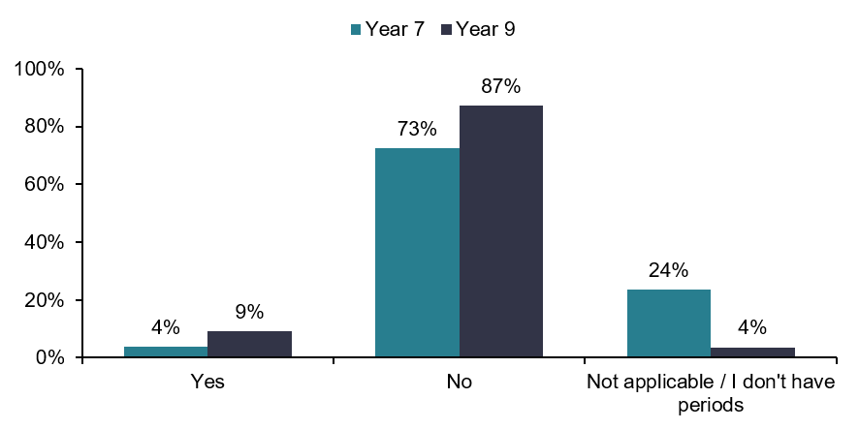
*Percentage of children who answered they were a girl
Figure 26 Answers to the question – ‘Have you ever experienced not being able to purchase period products because you couldn’t afford them?’.
In Year 7 girls with special educational needs (10% compared to 2% of children who did not have special educational needs) and those who lived in more deprived areas were more likely to experience period poverty (4% in the most deprived areas compared to 1% in the least deprived). In Year 9 girls who are young carers were more likely to have experienced period poverty (18% compared to 8% of girls who are not carers). Girls experiencing period poverty were more likely to be scared to go to school due to bullying (21% vs. 11%) and less likely to be happy than other girls (35% vs. 59%).



Digital Inclusion
13% | of Year 7 children were affected by lack of access to a device for learning or are missing out because to a lack of data or online access

1 in 10  | Lower | 5%  | Access
children in Year 7 felt they miss out some or all of the time due to lack of online access | levels of digital inclusion were seen in some groups including those children with special educational needs | of Year 7 children never or only some of the time had access to a device for learning at home | to a device for learning was lower in Year 7 than Year 9

Digital inclusion means making sure everyone can access and use the online content they need, including having access to suitable devices and data connections. Children increasingly need access to online content for schoolwork and learning online.
The majority of children in Year 7 and 9 access to a device for learning all or most of the time (Year 7:95%, Year 9:97%) and most children never or only some of the time felt they were missing out due to a lack of data or access (Year 7: 90%, Year 9: 91%) (Figure 27).
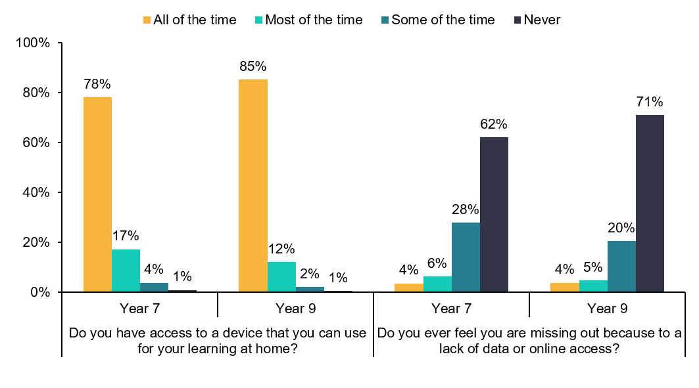
Figure 27 Responses to digital inclusion questions.
There were inequalities for some; children with special educational needs, young carers and those from ethnic minority backgrounds were more likely to have lower levels of digital inclusion.

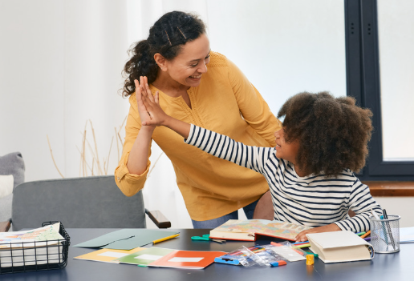

Neurodiversity (Year 9)
22% | of Year 9 children identified as neurodiverse in the survey

50% | 35% | Lower  | 30% 
reported feeling  happy with life at  the moment | had low mental wellbeing scores | levels of feeling safe in different settings, including home, school, and online | reported needing extra help at school

For the first time this year, children in Year 9 were asked whether they identified as neurodiverse (they were not asked if they had received a medical diagnosis). Neurodiversity regards differences in brain function and behavioural traits as part of normal variation in the population. It can include autism, ADHD (attention deficit hyperactivity disorder), dyslexia, dyspraxia, dyscalculia, and Tourette syndrome, as well as neurodevelopmental conditions. Uncovering the strengths of neurodiverse people and utilising their talents can help increase innovation and productivity of society as a whole.
Self-identification as neurodivergent is becoming more prevalent. The percentage of Year 9 children who identified as neurodiverse in the survey (22%) is on the higher side of national estimations of clinical prevalence, which are around 10-20%. Children and young people’s referral pathways are more established than adults in this area, however younger people may also be more likely to identify as neurodiverse, or identify with some characteristics of neurodiversity, due to an increase in neurodiversity awareness, more exposure on social media, and greater neurodiverse representation online, in media and in TV/film.
These results are being regarded as experimental statistics as this question was being asked to Year 9 children for the first time and further development of the self-identified approach may be required in the future.
50% of neurodiverse Year 9 children reported feeling happy with life at the moment, which was lower than their neurotypical peers (68%).
Almost a third (35%) of neurodiverse Year 9 children had low mental wellbeing scores, compared to around one in six (18%) neurotypical children, and higher levels of feeling lonely some or most of the time.
Neurodiverse children felt less safe than their neurotypical peers in the area in which they lived, at school, at home, on public transport, and online (Figure 28).
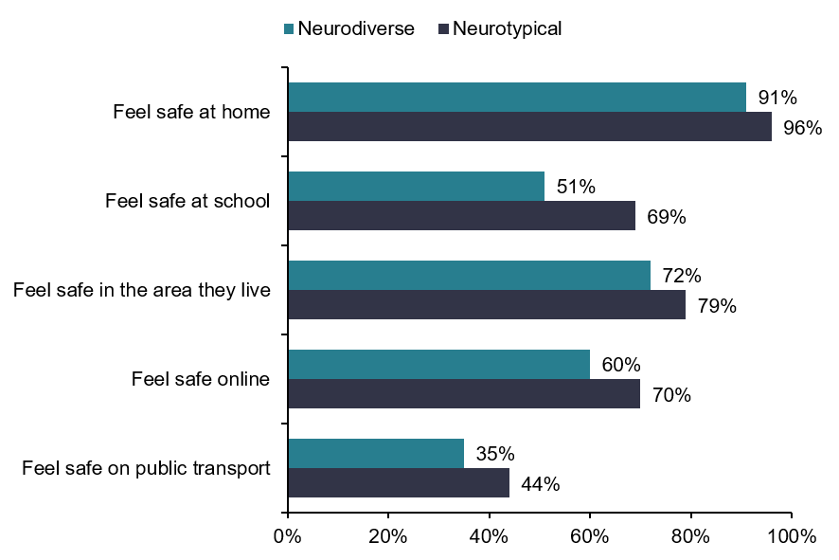
Figure 28 Percentage of Year 9 children reporting that they feel safe in different settings, by self-identified neurodiversity.
Almost one in three neurodiverse Year 9 children (30%) reported needing extra help at school and neurodiverse children were more likely to be bullied than their neurotypical peers. Thinking about the future, neurodiverse Year 9 children were less optimistic across all areas than their neurotypical peers. This included their health, job prospects, living independently, having enough money, having somewhere secure to live, relationships with family and friends, and climate change.

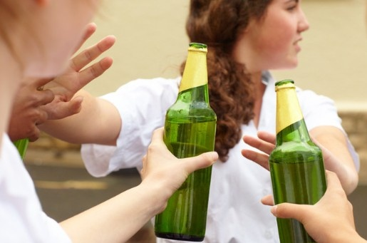

Alcohol and Drugs

Alcohol
More than half | of Year 9 children had never drank alcohol

14%  | Upwards | 25% 
of Year 9 children thought it was OK for people their age to get drunk | trend in the percentage of Year 9 children who had never tried alcohol | of Year 7 children had drunk alcohol once or twice

Children in Years 7 and 9 were asked if they had tried or drank alcohol more regularly and whether they thought it was OK for people their age to get drunk.
The percentage of respondents who had never consumed alcohol decreased with age with 71% of Year 7 children and 55% of Year 9 children having never drank alcohol (Figure 29), up from 39% in 2020.
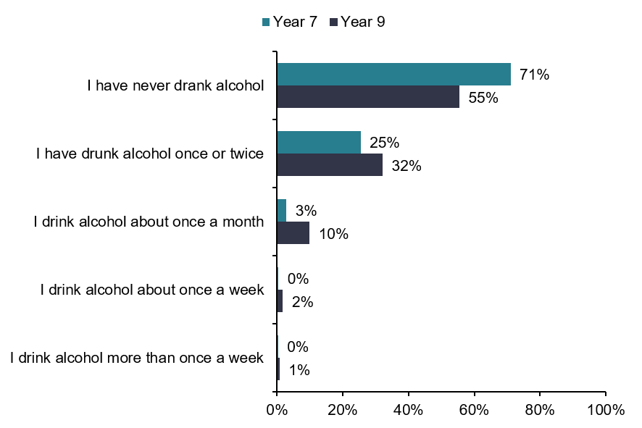
Figure 29 Frequency of alcohol intake by year group.
The percentage of respondents who have tried alcohol has decreased over time (Trends for Year 9: Figure 30), this is similar to national trends from the Health Survey for England.
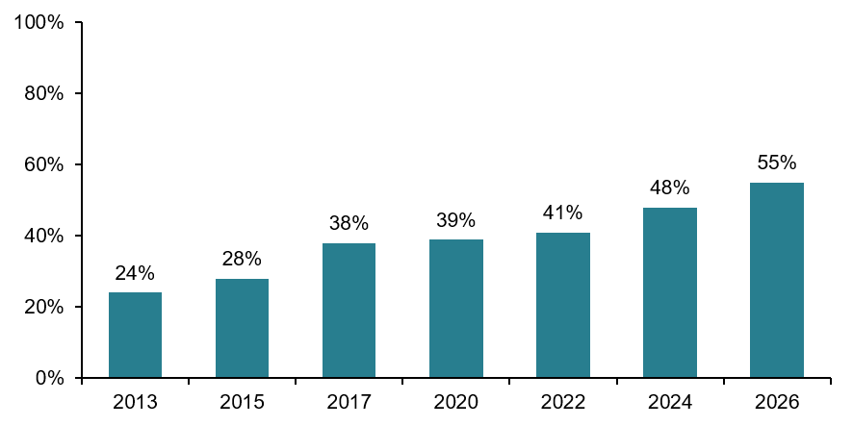
Figure 30 Trends in percentage of Year 9 children who had never tried alcohol.
In Year 7 girls were more likely to have never drank than boys but in Year 9 there was no difference between boys and girls. Children from ethnic minority backgrounds were less likely to have tried alcohol across Year 7 and Year 9.
Four percent of Year 7 children thought it was okay for people their age to get drunk, increasing to 14% for Year 9 children. Those who drank alcohol once a month or more were more likely to think it was okay to for people their age to get drunk (Figure 31).
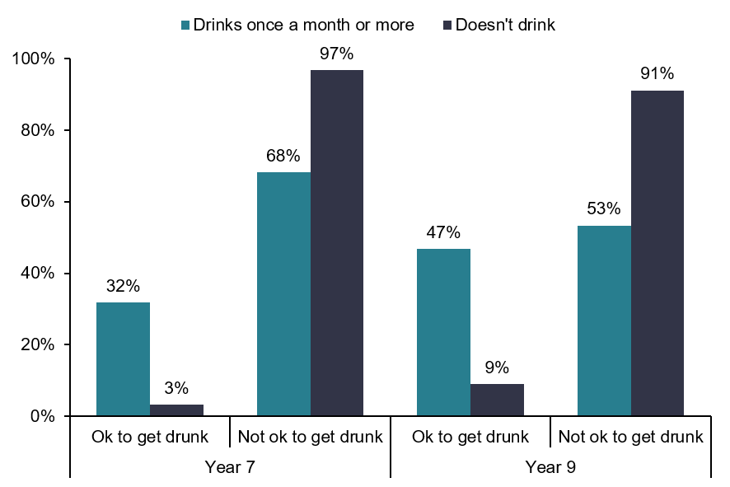
Figure 31 Percentage of children who thought it was OK for children their age to get drunk,
by alcohol intake.

Drugs

11%  | Similar | 1.25%
of Year 9 children had been offered cannabis | the percentage of Year 9 children who have tried cannabis was 3% (similar to previous years 3-5%) | of Year 9 children had been offered ketamine

The children in Year 9 were asked some questions relating to drug use, including whether they had been offered or used a number of specific drugs.
Overall, a relatively low proportion of Year 9 children had been offered or taken the drugs asked about; 1.25% had been offered ketamine and 0.24% had taken it, 4% had been offered nitrous oxide and 3% had taken it and 11% had been offered cannabis and 3% had taken it. A 2022 national survey found that children aged 11-15 years old were almost twice as likely to have been offered cannabis than any other individual drug, with 17% of children having been offered cannabis. There were some inequalities when looking at Year 9s who had been offered cannabis; those with special educational needs and those living in more deprived areas of the district were more likely to have been offered cannabis.

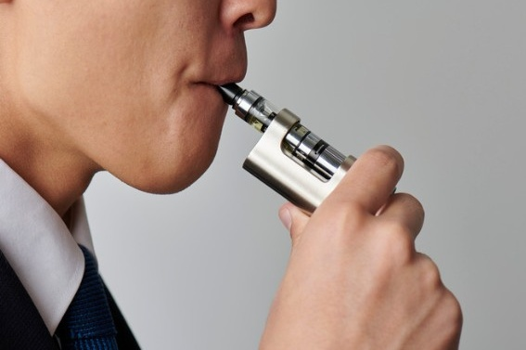

Smoking and Vaping
98% | of children in Year 7 had never tried smoking a cigarette

4 in 5 | 2%  | 15%  | 12%
Year 9 children had never used a vape | of all children thought it was OK for people their age to smoke | of Year 5 children had someone who smokes in their home | of Year 7 and 9 children who had never tried smoking had tried a vape

Survey participants were asked a number of questions about their own smoking and vaping opinions and behaviour, as well of those around them.
Almost all Year 7 children (98%) had never tried smoking a cigarette, this decreased slightly to 95% in Year 9 children. The percentage of those who have never smoked has increased since previous surveys (Year 9 trends in Figure 32). A similar trend is being seen nationally in the Health Survey for England where the percentage of 8-15 year olds who had tried cigarettes is down from 19% in 1997 to 2% in 2024.
Children with special educational needs in both Years 7 and 9 were more likely to have tried smoking.
In Year 9, girls were more likely than boys to have tried smoking, as were young carers.
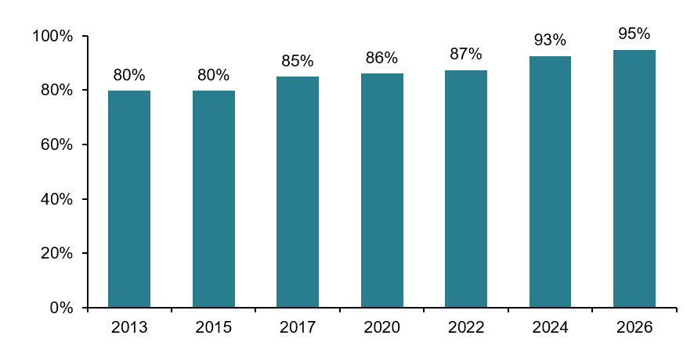
Figure 32 Trends over time for the percentage of Year 9 children who had never tried smoking.
When asked about vaping, nine in ten (91%) Year 7 children had never tried using a vape, this decreased to four in five (79%) in Year 9 children (Figure 33). Levels were similar to previous survey years for both Years 7 and 9. Although 21% of Year 9 children had tried vaping, only 2% said that they use vapes every day. Of those that vape weekly, 50% of Year 7 children and 24% of Year 9 children would like to stop.
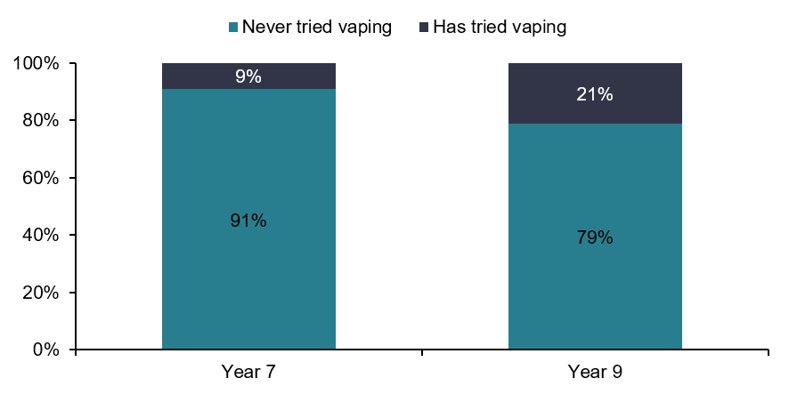
Figure 33 Summary of responses to the question ‘Vaping: Which describes you best?’.

Young carers in Years 7 and 9 had higher levels vaping, as did those with special educational needs and children living in the district’s most deprived areas. In Year 9, girls were more likely to have vaped than boys, as were those of White British ethnicity (Figure 34).
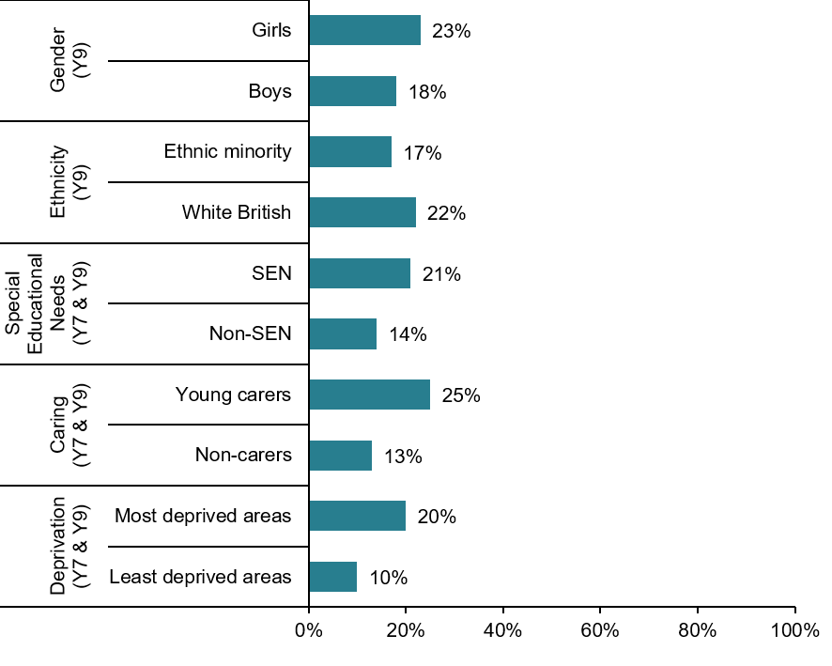
Figure 34 Percentage of children who had tried vaped, by inequality.
Comparing those who smoked and vaped in Years 7 and 9, most children who had tried smoking had also tried a vape (86%); and around one in ten (12%) of those who had never tried smoking had tried a vape.
Children who are exposed to smoking and environmental tobacco smoke at a young age are at increased risk of respiratory problems like asthma and chest infections and are also more likely to take up smoking themselves. Less is known about passive exposure to vaping and the effects it may have on their health.

When looking at environmental exposure to cigarette smoking and vaping, levels of vaping were higher than smoking in the home and car (Figure 35).
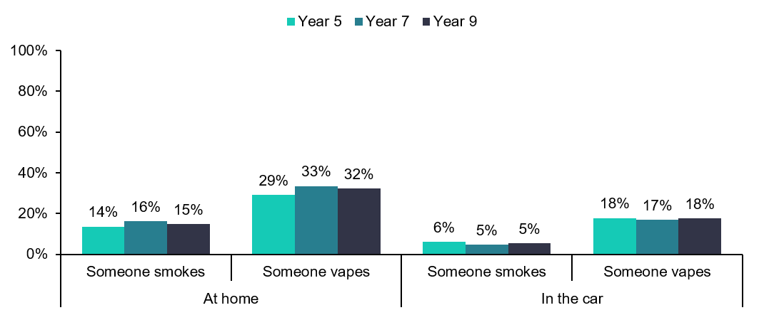
Figure 35 Percentage exposed to other people smoking or vaping in the car or home.
Children from ethnic minority backgrounds were less likely to have someone who vaped in the home or car. Children living in the district’s most deprived areas and those with special educational needs reported higher levels of smoking and vaping in their home and car. In Years 7 and 9, young carers were at higher risk of being exposed to someone smoking or vaping in the home and car.
In addition, Year 9 children who reported smoking or vaping at home were more than three times as likely to have tried smoking and twice as likely to have tried vaping than those who did not.
Across both Years 7 and 9, children were more likely to think it was okay for others their age to vape than it was to smoke cigarettes (Figure 36).
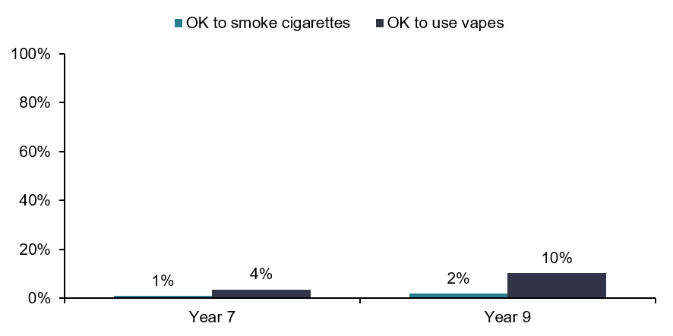
Figure 36 Percentage of children who think it is okay for young people their age to smoke or vape.



Gambling
78% | of children in Year 7 and 9 had tried one of the gambling activities asked about in the survey in the last 12 months. This is an increase of 9% compared to 2024.

12%  | 6%  | Boys 
of children in Years 5, 7 and 9 bought in-game currency to level up on a game every day or most days, which was the most common form of gambling. | of children in Years 7 and 9 had taken part in a non-gaming related gambling activity every day or most days. | were more likely than girls to gamble.

In the survey there were questions about the frequency of taking part in the following types of gaming and gambling activity in the previous 12 months. Years 5, 7 and 9 were asked if they had:
- Bought an in-game currency to move up a level whilst gaming (e.g. coins, robux, v-bucks)
- Skin gambling on online games
- Bought a ‘loot box’ whilst gaming (e.g. FIFA/FC26 packs, Fortnite packs, Star Cards)
Years 7 and 9 were asked if they had:
- Used a fruit machine/slot machine
- Placed a private bet with friends
- Bought a lottery ticket or scratch card
- Put a bet on a sporting event
The proportion of children not partaking in any of the listed gambling activities in the previous 12 months has decreased compared to previous surveys (Figure 37). Around two in ten children (22%) in Years 7 and 9 had not participated in any of the listed gambling activities in the previous 12 months. (Previous surveys were around three in ten).
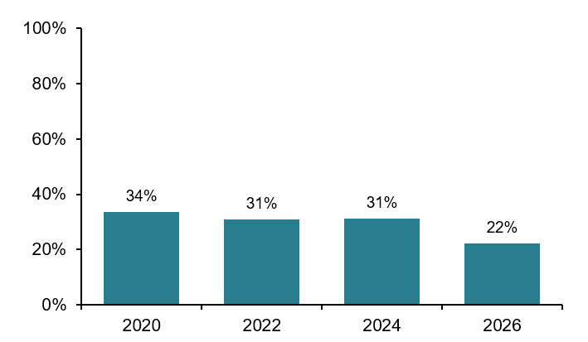
*The question was not previously asked to Year 5 children, so trends cannot be analysed for this year group.
Figure 37 Trends over time for the percentage of Year 7 and Year 9 children who have not taken part in any gambling activity in the last 12 months.
Whilst the proportion of children not partaking in a gambling activity in the previous 12 months has decreased, some of the questions were phrased differently compared to previous surveys. Children were asked if they had bought an ‘in-game currency’ rather than ‘coins’ and given examples of what this could mean. Examples were also provided for how a ‘loot box’ may be bought. This additional guidance may have impacted on how children answered the question.
The most common form of gambling was buying in-game currency to move up a level on a computer game with 73% of Year 5, 74% of Year 7 and 74% of Year 9 taking part in this activity in the last 12 months (Figure 38).
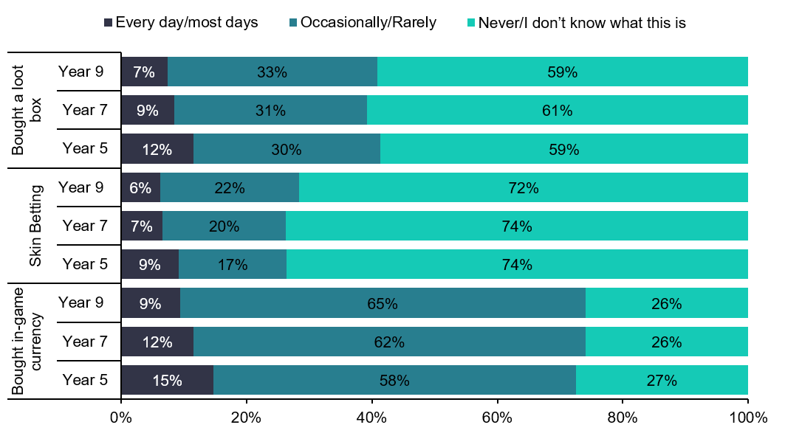
Figure 38 Frequency of gambling by year group for gaming related gambling types.
Just over half of children (52%) in Years 7 and 9 have taken part, at least once in the last 12 months, in a non-gaming related activity, though the proportions who do this more regularly (every or most days) are lower (Figure 39).
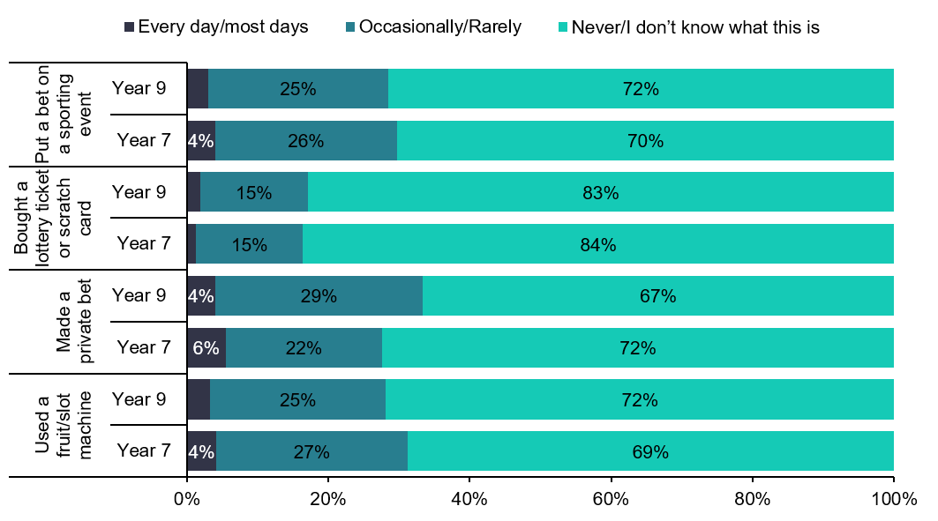
Figure 39 Frequency of gambling by year group for non-gaming related gambling types.
85% of boys had taken part in at least one gambling activity and were more likely than girls (71%) to have taken part in gambling, especially those types of gambling relating to online gaming. This could be due to higher proportions of boys who participate in online gaming compared to girls though boys were also more likely to have taken part in non-gaming related gambling. Boys and children with special educational needs were more likely to have taken part in gaming related activities. Boys, children with special educational needs, and young carers were more likely to have taken part in non-gaming related activities.
Of those children in Years 7 and 9 who had participated in a gambling activity in the last 12 months, nearly four in five (79%) said their parents were aware.

Appendix 1 Survey Participants
Results in this appendix refer to the children who completed questionnaires in Year 5, 7, and 9 who are included in this report.

Gender
All children were given the opportunity to state their gender. 49% of respondents were girls and 49% were boys. The remaining 2% described their gender in some other way, did not know, or left the question unanswered (options offered varied by year group). There were no major differences in the gender split between the different year groups. Analysis by gender presented in this report does not include those who described their gender in some other way due to the small number of children involved.

Deprivation
Children in Years 7 and 9 were asked for their home postcode. This was used to determine the Index of Multiple Deprivation (IMD) quintile of the neighbourhood in which the children live compared to all neighbourhoods in the Wakefield District. (The analysis uses within-district deprivation quintiles, not the all-England quintiles). 44% of children either did not provide a postcode, did not provide a valid postcode or provided one outside the Wakefield District which were not included, and therefore their deprivation quintile could not be assigned. The neighbourhood deprivation of Year 5 children was based on the postcode of the school.
Of those that did respond, there was a reasonable spread of responses from children across the different IMD quintiles (Figure 40).
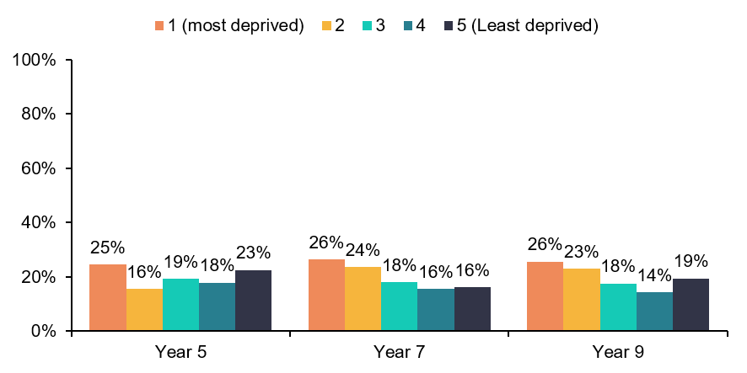
Figure 40 Percentage of children in each local IMD 2025 deprivation quintile for those who had an IMD quintile assigned.

Ethnicity
Ethnicity was asked of children in Years 7 and 9 of whom 3% answered ‘Don’t know’ or ‘Don’t want to say’. The profile from those who did state their ethnicity (Table 7) was consistent with that seen in the 2021 Census, for the first time in 2026 the option of giving ethnicity of Gypsy, Traveller or Roma was included. Results were compared between children of White British ethnicity and children from other ethnic minorities.
Ethnicity | Year group |  | All Years
Ethnicity | 7 | 9 | All Years
White British | 78% | 76% | 77%
Gypsy, Traveller, or Roma | 1% | 1% | 1%
White non-British | 5% | 5% | 5%
Asian / British Asian | 7% | 9% | 8%
Black / African / Caribbean / Black British | 5% | 5% | 5%
Mixed / Multiple ethnic groups | 3% | 3% | 3%
Any other ethnic background | 1% | 2% | 1%
Table 7 Ethnicity of survey respondents.

Special Educational Needs
Children were asked if they received extra help at school with their learning or behaviour from someone other than a teacher. The proportion of children in Years 5, 7 and 9 answering ‘Yes’ (Figure 41) are similar for Year 5 and Year 7 but lower for Year 9 compared to national data on percentages of children with an Education, Health and Care Plan (EHCP) or SEN support in state funded primary and secondary schools by year group for Wakefield local authority (Year 5: 23%, Year 7: 21%, Year 9: 21%) .
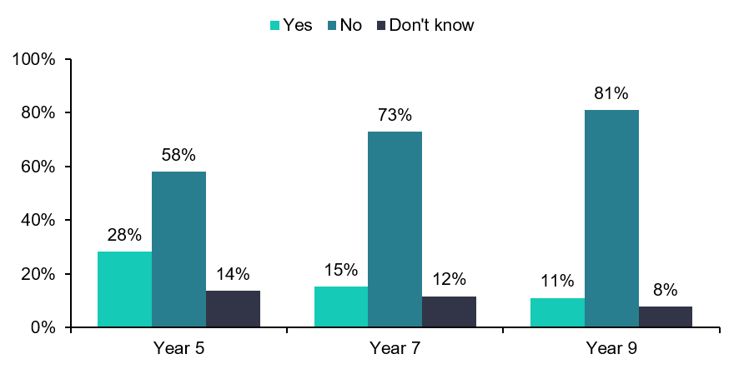
Figure 41 Percentage of children who said they had extra help at school.

Young Carers
12% of all children in Years 5, 7 and 9 said they look after, or help, someone in the family who is disabled or ill; 73% said they did not, and 15% did not know (Figure 42). There is no consensus about the true extent of young caring nationally. The 2021 Census showed only 1% of 5–15-year-olds in Wakefield District as providing unpaid care. While a national survey in 2018 found that 22% of young people aged 11 to 15 years in England lived with someone who suffered from an illness or a disability and who they helped to look after and do things to help them around the home.
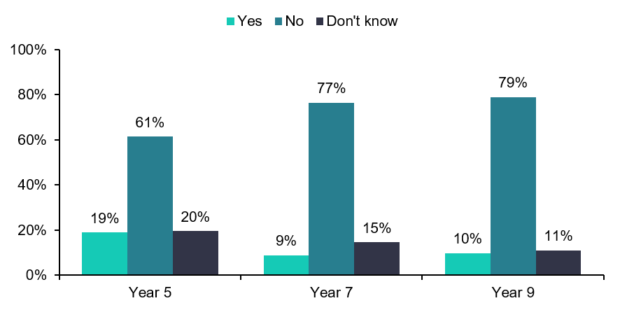
Figure 42 Percentage of young carers in each year group.

Appendix 2 General Methodology and Terminology

Children
Within this report, participants in Year groups 5, 7 and 9 are referred to as children.

Calculating Deprivation Inequality
The Index of Multiple Deprivation (IMD) is the most commonly used official measure of deprivation used in England. It was last calculated in 2025 and combines 55 indicators across 7 domains to give an overall picture of living conditions in an area. Deprivation scores are published for Lower Super Output Areas (LSOA) and can be grouped into quintiles. In this report quintile 1 contains the 20% most deprived neighbourhoods in Wakefield District and quintile 5 contains the 20% least deprived.
For the Children and Young People’s Health Survey, children in Year 5 were allocated to the deprivation quintile based on the postcode of their school. Those in Years 7,9 and 12 were asked to give a home postcode and this was used to calculate their deprivation quintile of the neighbourhood in which they live. Some children provide postcodes from outside the Wakefield District even though they attend a Wakefield school and deprivation decile was set as not known for these children.

Significance Testing and Confidence Intervals
Chi-squared tests have been used to test hypotheses that some children answer differently to some questions that other children. Results where the findings were statistically significant (p<0.05) are discussed further in the text.
95% confidence intervals are presented in some figures comparing the findings from 2024 to previous survey years. These were calculated using the Wilson Score method as this is the one most used in national government publications of population figures such as the Office of Health Improvement and Disparities (OHID) Fingertips health profiles.
The chi-squared test for trend has been used to test the significance of trends over time for a limited number of questions that have been asked in a consistent way since 2013. This is the test currently used in the OHID Fingertips profiles to indicate trend.

Short Warwick-Edinburgh Mental Wellbeing Scale
The general mental wellbeing of children in Years 7 and 9 was measured using the Short Warwick-Edinburgh Mental Wellbeing Scale (SWEMWBS), a scientifically validated set of questions. It focuses on positive aspects of mental health rather than mental illness.
It includes questions on feeling optimistic about the future, feeling useful, feeling relaxed, dealing with problems well, thinking clearly, feeling close to other people, and being able to make up their own mind about things.
A higher score suggests better mental wellbeing, whilst a lower score suggests poorer wellbeing. Scores between 7 and 19 were categorised in this report as ‘low mental wellbeing’, scores between 20 and 27 as ‘good mental wellbeing’ and scores between 28 and 35 as ‘high or max wellbeing’.

Appendix 3 Theming Open-Ended Responses
This year's survey included two new open-ended questions:
- "What are three things that you think make a good and happy life?" and
- "Thinking about your life right now, what are the three things you worry about the most?"
These questions were designed to provide a deeper understanding of what children value most in their lives, as well as the issues and concerns they experience at different stages of childhood.
Responses to each question were collated and entered into Microsoft Copilot to support the thematic categorisation of responses. No personal or identifiable information was included in this process. The initial themes generated were reviewed and refined by analysts in the Public Health Intelligence Team, who also checked and, where appropriate, amended the theme assigned to each individual response. The final themes were then used for the analysis presented in this report.

NHS England (2022) Live Well. 5 A Day portion sizes
NHS How to eat a balanced diet - NHS
Department of Health and Social Care (2025) Banning the sale of high-caffeine energy drinks to children: impact assessment, Banning the sale of high-caffeine energy drinks to children - GOV.UK
NHS England (2025) Healthy teeth and gums - NHS
NHS (2024) Physical activity guidelines for children and young people
UNICEF (2022) The Necessity of Urban Green Space for Children’s Optimal Development
Warwick-Edinburgh Mental Wellbeing Scale (WEMWBS) © University of Warwick 2006, all rights reserved.
University of Leeds (2017) Lack of sleep damaging for children.
Bernado’s (2023) What is bed Poverty?
Armitage, R (2021) Bullying in children: impact on child health
Spectrum Health (2024) Condoms and C-Card
Girls Helping Girls Period (2024) What Causes Period Poverty?
The Brain Charity (2022) Neurodivergent, neurodiversity and neurotypical: a guide to the terms
NHS England (2024) Health Survey for England, 2024 - NHS England Digital
NHS England (2022) Smoking, Drinking and Drug Use among Young People in England, 2021
NHS England (2024) Health Survey for England, 2024 - NHS England Digital
NHS (2026) Passive smoking
Action on Smoking and Health (2025) Young People and Smoking - What factors influence children to start smoking? p.3
Department for Education (2025) Special Educational Needs in England 2025
Wakefield JSNA (2024) Unpaid Carers
Joseph, S et al. (2019) Young carers in England: Findings from the 2018 BBC survey
Ministry of Housing, Communities and Local Government (2025) Local Deprivation Explorer 2025
Association of Public Health Observatories (2010) Technical Briefing 3: Commonly used public health statistics and their confidence intervals
OHID (2020) Technical Guide - Fingertips trend markers

